Name: _____________________________________________ Date: ______________
Thickness (Number of Layers) | Breaking Weight (Number of Pennies)
1
2
3
4
5

- Describe the pattern of change in the data. Then, use the pattern to predict the breaking weights for bridges 6 and 7 layers thick.

- Suppose you could use half-layers of paper to build the bridges. What breaking weights would you predict for bridges 2.5 layers thick and 3.5 layers thick.

- How would you expect your results to change if you used a stronger material, such as poster board or balsa wood, to make your bridges?

- It is unlikely that your (thickness, breaking weight) data fit a linear pattern exactly. Below are two students’ attempts to draw lines to model their group’s data.
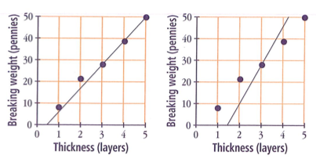

  - Which graph model would allow the students to make better predictions about breaking weights for bridges of different thicknesses? Why?

  - Do you have any suggestions for how the students could change the graph model you chose in part a to help them make even better predictions?

- For each graph below, try to find a graph model that fits the experimental data as closely as possible. Compare your graph models with those drawn by others in your group. What strategies did you use to help you draw an appropriate graph model?
