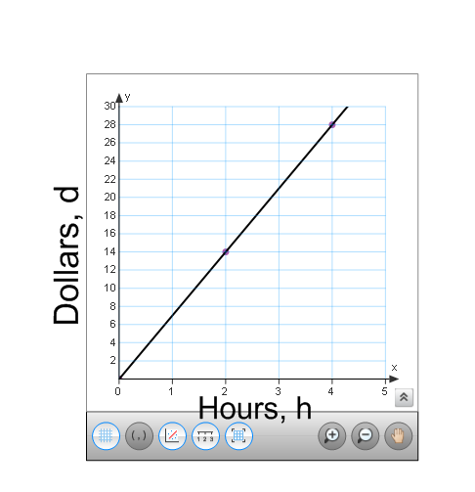
Jonathan and Cindy are both selling hot chocolate at their school fundraiser. Cindy’s data for how much hot chocolate she sold is represented in the graph below. Jonathan’s data is represented in the table. Each sells a cup of hot chocolate for $1 per cup.
HOURS, h | DOLLARS, d
2 | 10
3 | 15
4 | 20
5 | 25
6 | 30
Cindy’s Sales Jonathan’s Sales

Part A. Determine how many cups of hot chocolate each student sells per hour.

Cindy _________ cups per hour Jonathan __________ cups per hour

Part B. Write an equation for each student that shows the amount of dollars “d” made after “h” hours.

Cindy’s equation ______________ Jonathan’s equation ______________
Part C. If each student sells hot chocolate for 10 hours, who would make more money? How much more?
Show your work.

Answer ____________________ by _______________ dollars.
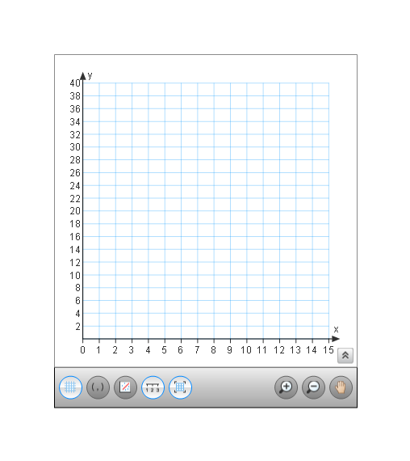
Part D. David, another student in the class, decides to sell hot chocolate for $ 0.75 per cup. He began to record his earnings below. The table shows how much money David earned in dollars, d, after h hours. Complete the table, make a graph(be sure to label the axes), and write an equation that represents David’s sales.
Table Graph
Hours, h | Dollars, d
3 | $9
4 | $12
5 | $15
6
8
12

Equation:
d = ___________

Part E. Are the functions that represent these three students’ sales of hot chocolate linear? How do you know?
_______________________________________________________________________________________________________________________________________________________________________________________________________________________________________
Part F. Look at the function equations for each of the three students. Explain how you would be able to determine which student made more money per hour, just by comparing the equations.
_________________________________________________________________________________________________________________________________________________________________________________________________________________________________________________________________________________________________________________________________________________________________________________________________
Part G. The table below shows the temperature of the students’ city and the number of total hot chocolate sales at their school fundraiser.
Temperature (Degrees, Fahrenheit) | Quantity of Cups of Hot Chocolate Sold
70 | 2
65 | 20
60 | 9
55 | 13
50 | 15
48 | 19
45 | 20
40 | 23
35 | 25
30 | 28

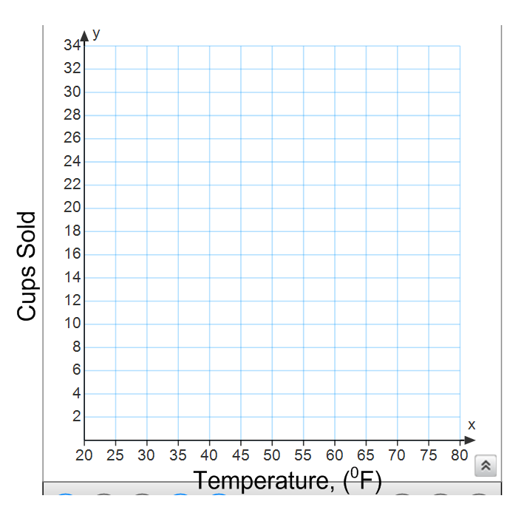
- Make a scatter plot on the grid to represent the data in the table. Title and label the scatter plot. Then sketch a line of best fit.

- Based on the scatter plot, describe the correlation, if any exists, between the temperature outside and the number of cups of hot chocolate sold.

____________________________________________________________________________________________________________________________________________________________________________________________________________________________________________________________________________________

- Which ordered pair represents the outlier? ______________

- Hypothesize a possible scenario that explains the presence of this outlier.

__________________________________________________________________________________________________________________________________________

