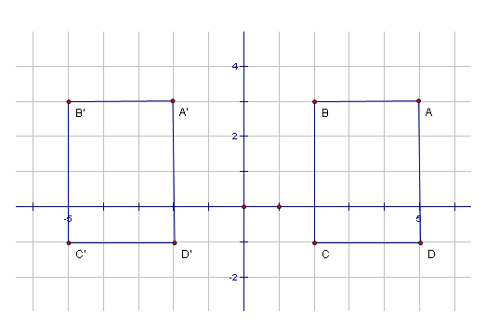
2.

- List the coordinates for the points in figure ABCD.
A ( , )
B ( , )
C ( , )
D ( , )

- List the coordinates for the points in figure A’B’C’D’.
A’ ( , )
B ‘ ( , )
C ‘ ( , )
D’ ( , )

- What type of transformation is shown above?

- Compare the coordinates of the figure ABCD and its image A’B’C’D’. Write a rule for this transformation.

- Triangle ABC has vertices A (4,3) , B (-7,0), C (6,5). When translated, A’ has coordinates (-1,3).

- Find the coordinates of B’ and C’ based on the translation applied to point A.
B’ ( , )
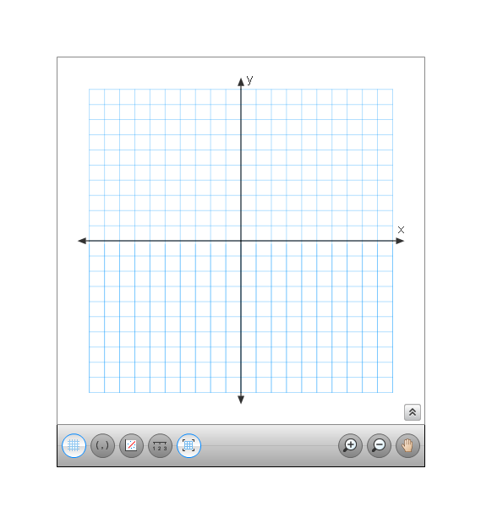
C’ ( , )

- Graph the original figure ABC and its image A’B’C’ on the set of axes below:

- Describe the translation that gets you from ABC to A’B’C’.
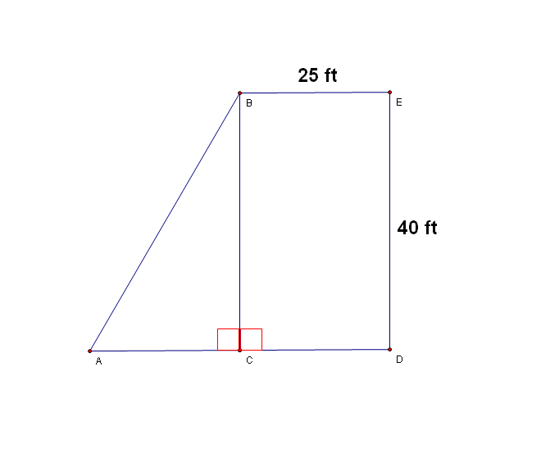
3.

In the figure above, the length of segment AD is congruent to the length of segment DE.
- Find the length of segment CD ___________________

- Find the length of segment AC ___________________

- What is the length of segment AB? Round your answer to the nearest tenth. Show all your work.

4. The original package for FREEBIES Cereal Company is shown to the right. The company wants to design a new package with the SAME VOLUME.

- If the HEIGHT of the new package is TWICE as large as the current height, what are some possible values for the length and width of the new box?

- The company wants the length of the new box to be one inch longer than the width. If this is the case, what are the values for the length and the width of the new box? Explain your reasoning.

