Name _________________________________ IS259

Class _____________ Grade 8 Math

**Exam: Transformations**

PLEASE FOLLOW ALL DIRECTIONS CAREFULLY. ANSWER ALL QUESTIONS ON GRAPH PAPER.

1) Name the four types of transformations we have investigated in class.

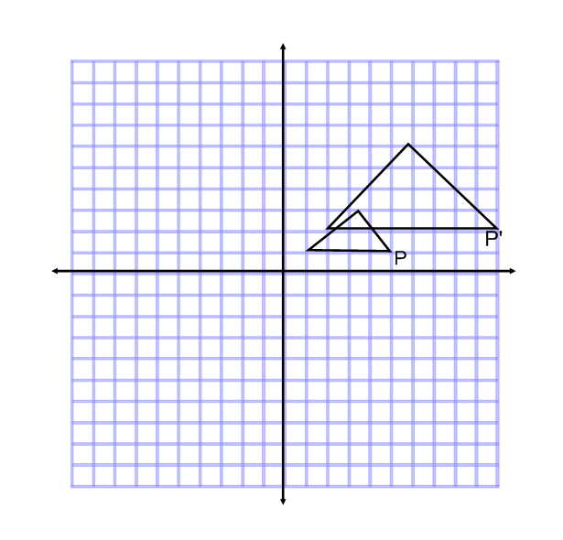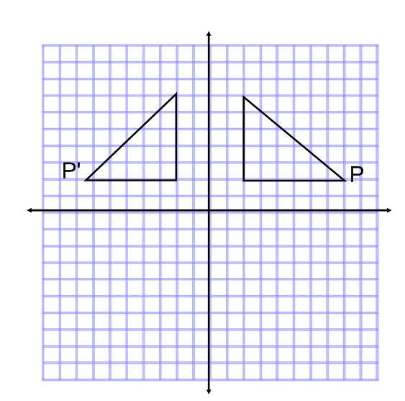***Choose 5 of the following. Name the type of transformation that will give you the image of the original figure.***

2) 3)

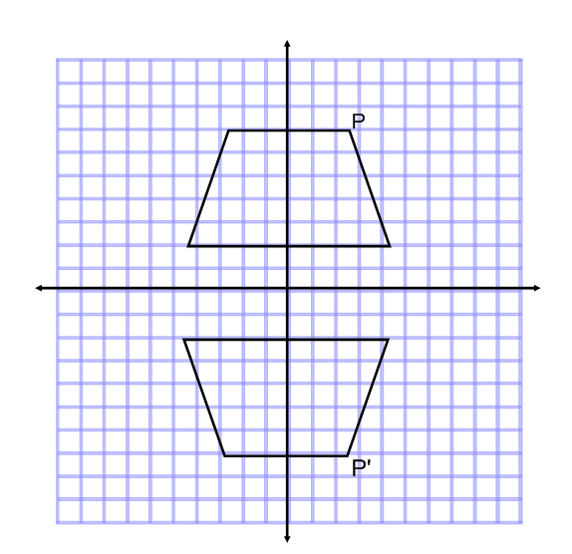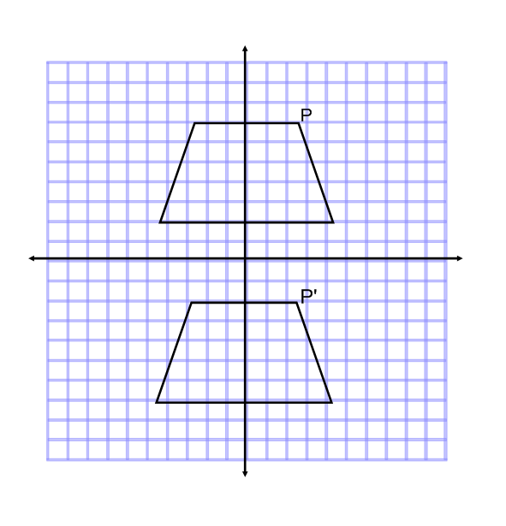

4) 5)

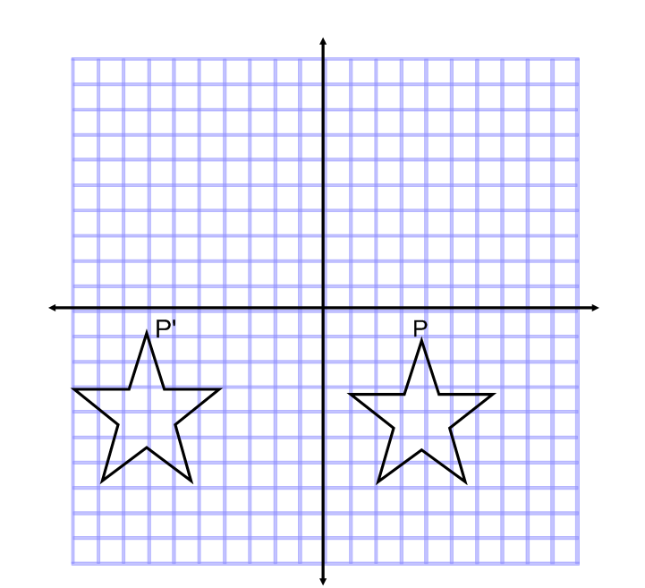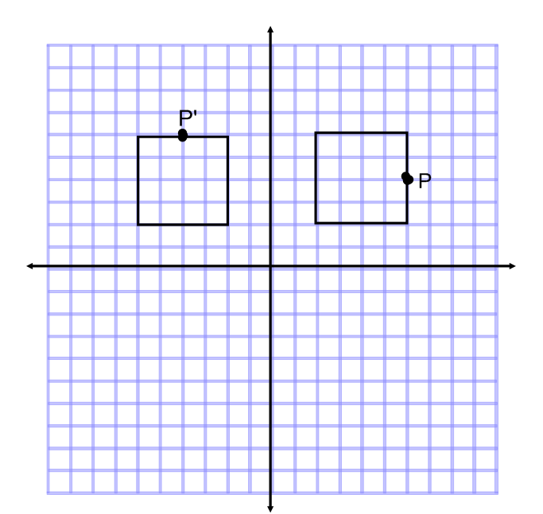

6) 7)

**Answer TWO of the following. Please provide a *FULL EXPLANATION*. THIS MEANS *COMPLETE SENTENCES.***

8) James said that the in order to get from ABCD to A’B’C’D’, you could reflect the image across the y-axis. Do you agree with James? Why or why not?



9) Hussein wrote on his test that in order to get the image J’K’L’, that you would rotate the figure JKL 90° counterclockwise about the origin. Do you agree with Hussein? Why or why not?

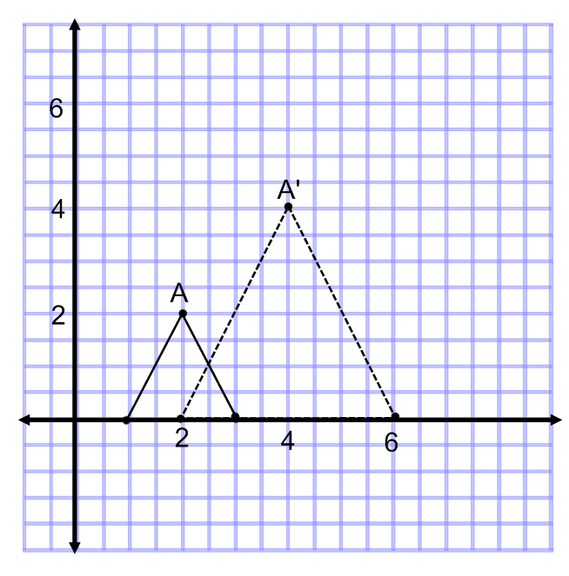

10) Juan put on his test that to get the figure A’B’C’, the original ABC must be dilated by a SCALE FACTOR of 3. Do you agree with Juan? Why or why not?

**You MUST answer the following question. Complete all parts on ONE set of axes.**

11) a) Plot the figure ABC, given the coordinates A ( - 5, 3) ; B (-3, 7) ; C ( - 4, 2)

b) Reflect ABC over the x –axis. Label the image A’B’C’. List the coordinates of each point.

c) Now reflect the image A’B’C’ over the y-axis. Label the image A’’B’’C’’. List the coordinates of each point.

d) What other transformation will get you from ABC to A’’B’’C’’ ?

**Choose TWO of the following questions. Make a set of axes for EACH QUESTION. Read the directions carefully!!!**

12) a) Plot the figure JKLM given the coordinates J ( -6, 3) ; K ( -4, 7) ; L (-2, 6) ; M (-1, 1)

b) Translate the figure 1 unit up and 8 units to the right. Label J’K’L’M’ and list coordinates.

c) Rotate the figure J’K’L’M’ 180 ° counterclockwise about the origin. Label J’’K’’L’’M’’ and list coordinates.

Rule:

13) a) Plot the figure DFG given the coordinates D (1, 1) ; F (3, 3) ; G ( 4, 1)

b) Dilate DFG by a scale factor of 2. Label the image D’F’G’ and list the coordinates.

c) Reflect D’F’G’ over the x – axis. Label D’’F’’G’’ and list the coordinates.

14) a) Plot the figure PRQ given the coordinates P ( 5, -2) ; R ( 8, 3) ; Q (5, 6)

b) Translate the figure 3 units down and 4 units to the left. Label image P’R’Q’ and list the coordinates.