Name all the Angle Relationships.
Do I remember how to do this?
Alternate Interior | 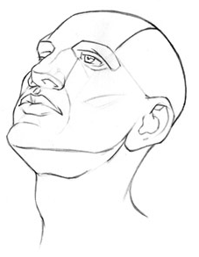  ∠_____ = ∠_____  ∠_____ = ∠_____
Alternate Exterior | ∠_____ = ∠_____  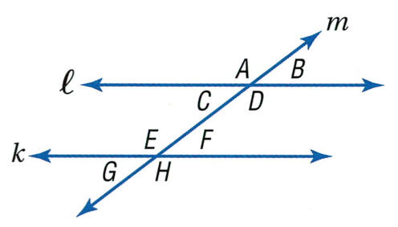  ∠_____ = ∠_____
Corresponding | ∠_____ = ∠_____  ∠_____ = ∠_____  ∠_____ = ∠_____  ∠_____ = ∠_____
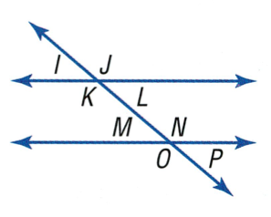  Vertical | ∠_____ = ∠_____  ∠_____ = ∠_____  ∠_____ = ∠_____  ∠_____ = ∠_____
If ∠ J is 125°, what is the measure of…
m∠ J = __________________________________________
m∠ L = __________________________________________
m∠ K = __________________________________________
m∠ I = ___________________________________________
m∠ N = __________________________________________
m∠ M = __________________________________________
m∠ O = __________________________________________
m∠ P = __________________________________________

∠I and ∠ L are __________________________________________________ angles.
∠I and ∠ O are __________________________________________________ angles.
∠L and ∠ N are __________________________________________________ angles.
∠K and ∠ N are __________________________________________________ angles.
∠J and ∠ O are __________________________________________________ angles.

Example 1: Solve for x in terms of Parallel Lines Cut by Transversals
Identify the angle relationship: _________________________________
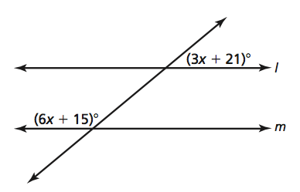
That means the angles…___________________________________
Set Up the Equation:

Check

x = ______________________________________

You Try 1!
Solve for x.
Identify the angle relationship: _________________________________
That means the angles…___________________________________
Set Up the Equation:

x = ______________________________________

Example 2: Find the Measure of Angles in Parallel Lines Cut By A Transversal
Find the measure of ∠CBA.
A
B
C
D
E
F
G
H
(6n + 3)°
(15 + 3n)°
C

Find the measure of ∠HFE.

You Try 2!
Find the measure of ∠DCE.
A
B
C
D
E
F
H
G
(x + 23)°
(2x − 27)°

Find the measure of ∠ACB.

Find the measure of ∠CDG.

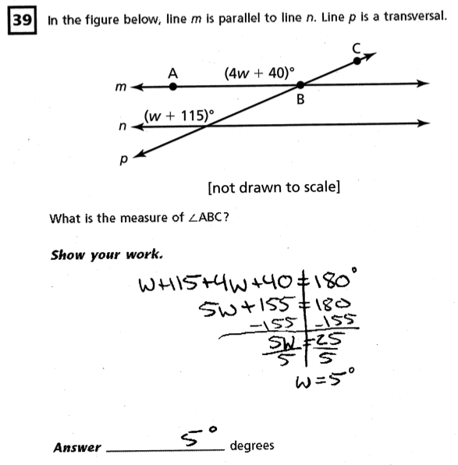
What do you think is a common BLUNDER in this type of problem? _________________________________________________________________________________________________________________________________________________________________________________________________________________________________
___________________________________________________________________________
What was this student’s mistake?

___________________________________________________________________________________________________________________________________________________________________________________________________________

Solve the problem correctly below.

Independent Practice:

Find the angle measure:

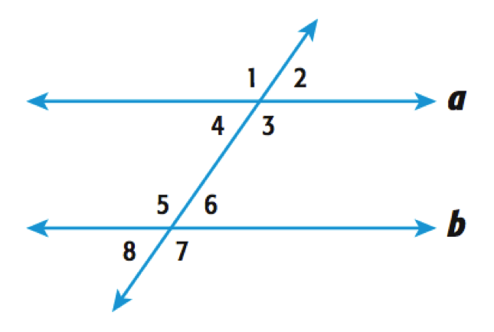m∠1 = ___________________________
(x + 37)°
(4x + 33)°
m∠2 = ___________________________
m∠3 = ___________________________
m∠4 = ___________________________
m∠5 = ___________________________
m∠6 = ___________________________
m∠7 = ___________________________
m∠8 = ___________________________
A
B
C
D
E
F
G
H

m∠ADC= ___________________________
(x + 37)°
(4x + 33)°
m∠ADE = ___________________________
(4n + 70)°
(10 + 7n)°
m∠BED = ___________________________
m∠BEF = ___________________________
m∠HEF = ___________________________
m∠DEH = ___________________________
m∠GDE = ___________________________
m∠CDG = ___________________________

(7x + 32)°
(3n – 15)°
C
D
A
B
H
G
E
F
L
K
I
J
O
P
M
N
(2x + 4)°

(n + 35)°
m∠A = ___________________________ m∠B = ___________________________
m∠C = ___________________________ m∠D = ___________________________
m∠E = ___________________________ m∠F = ___________________________
m∠G = ___________________________ m∠H = ___________________________

m∠I = ___________________________ m∠J = ___________________________
m∠K = ___________________________ m∠L = ___________________________
m∠M = ___________________________ m∠N= ___________________________
m∠O = ___________________________ m∠P = ___________________________

Homework: Homework #5

Exit Ticket:
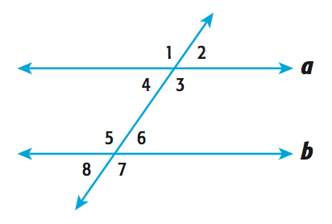

(2x + 72)°

(4x + 12)°

Find the measure of each angle.

m∠1 = ___________________________ m∠2 = ___________________________
m∠3 = ___________________________ m∠4 = ___________________________
m∠5 = ___________________________ m∠6 = ___________________________
m∠7 = ___________________________ m∠8 = ___________________________

