Name __________________________ Class Date:
PART 1: Match each word with its definition from the bank below:
Definition | Word
- Two angles whose sum measures 90˚

- Angles that are directly opposite each other at two intersecting lines. These angles are congruent.

- Angles that are on the inside of two parallel lines cut by a transversal, and are located on opposite sides of the transversal line. These angles are congruent.

- Angles which are directly next to each other.

- Congruent angles that are created where a transversal crosses two other parallel lines. These angles, one exterior and one interior, are located in the same place at each intersection and on the same side of the transversal.

- Lines that lie in the same plane and remain the same distance apart. These lines will never touch.

- A line that cuts two parallel lines.

Word Bank:
- Adjacent  - Transversal  - Vertical | - Alternate Interior  - Supplementary  - Complementary | - Parallel Lines  - Alternate Exterior  - Corresponding

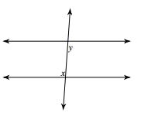
Identify the angle relationship in each figure:
8.  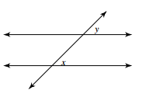  ______________________ | 9.  _________________________
10.  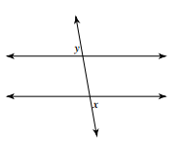  _________________________ | 11.  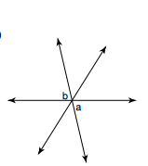  ________________________
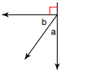  12.  ________________________ | 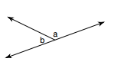  13.  ___________________________

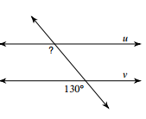
14. What is the measure of the angle marked with the question mark? Explain how you found your answer.

_____________
_________________________________________________________________

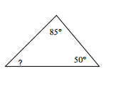
- In a given triangle, the measures of two of the interior angles are given. What is the measure of the third unidentified angle?
Answer ___________________
Show your work:

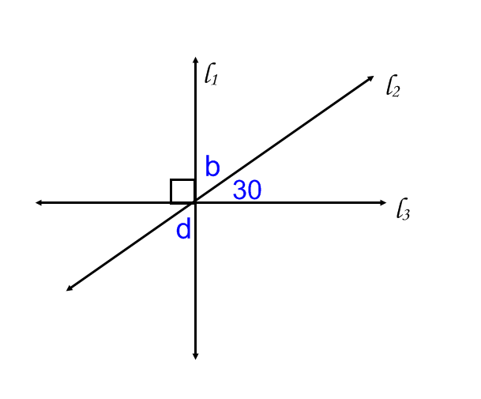
- Cindy told her teacher that, in the picture to the right, the measure of angle b was 60° and the measure of angle d was 30°. Critique Cindy’s response using your knowledge of angle relationships.

________________________________________________

________________________________________________

________________________________________________

________________________________________________

________________________________________________

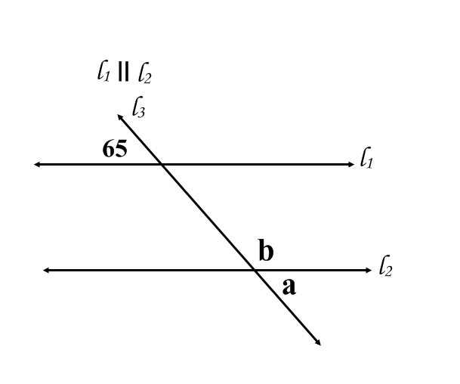
- What are the measures of angles a and b in the figure to the left? Explain below how you determined your answer.

m<a = __________ m<b = ____________

Explain:
___________________________________________________
___________________________________________________
___________________________________________________
___________________________________________________

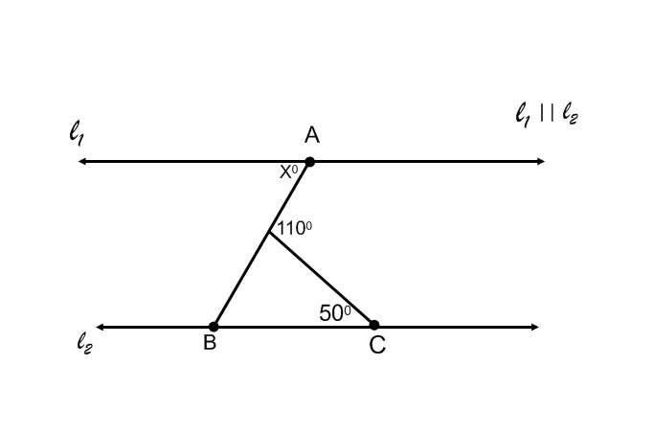
- Given the information in the figure to the right, find the value of x.
Show your work:

X = ______ °
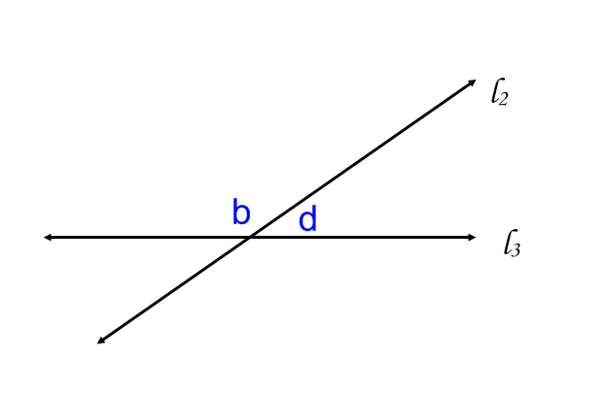
- m∟b = (3x + 40)º
m∟d = 2(x + 20)º
What is the measure of angles b and d? Show your work:

ANSWER:

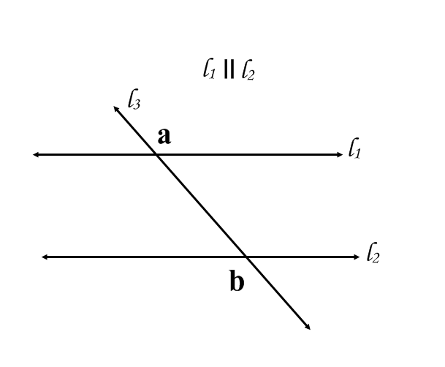
- What is the measure of angle b in degrees? Show your work!
m∟a = (5x – 10) º
m∟b = 2 (x + 40)º
ANSWER:

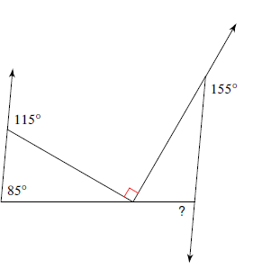
Challenge: Find the angle measure in degrees of the angle labeled with the question mark in the figure.

