Name_______________________ Class ________________ Date ___________
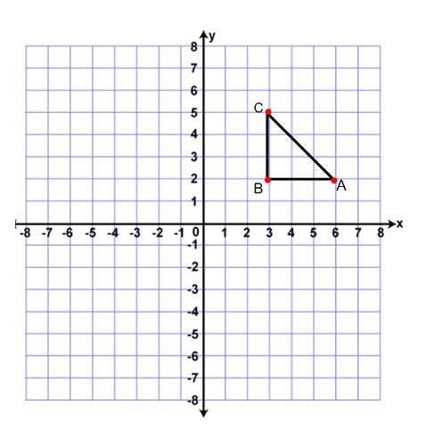
Open a new GSP document. Click the GRAPH tab at the top of the screen and then click SHOW GRID.
- Download the file on the homepage from Mr. Frangella’s website. Open the file. The figure should look like the one to the right.
- Record the coordinates of ABC below:
A : __________
B: __________
C: __________
- Highlight the entire figure (it should be bright purple). Click TRANSFORM, Rotate, 90 degrees. Then click DISPLAY, SHOW LABELS. Copy the resulting image on the graph to the right. Label this figure A’B’C’. Record the coordinates below:

A’ : __________

B’ : __________

C’ : __________

- What do you notice about the way the coordinates change? Can you make a generalization about rotating a point 90 degrees counterclockwise?
__________________________________________________________________________________________________
__________________________________________________________________________________________________
$***R_{origin, 90degrees}$ (x, y) → _______________

- Now let’s start with the original figure ABC and let’s rotate it 180 degrees to see what happens to the coordinates. Be sure to show the labels in the graph in the GSP program so you know which points are which. Draw the resulting figure below. Label it A”B”C” and record the coordinates.

A”: _____________
B”: ____________
C”: ____________

- What do you notice about the way the coordinates change? Can you make a generalization about rotating a point 180 degrees counterclockwise?
__________________________________________________________________________________________________
__________________________________________________________________________________________________
***$R_{origin, 180degrees}$ (x, y) → _______________

- Hypothesize (i.e. predict) what will happen to the coordinates of the original figure ABC if it is rotated 270 degrees counterclockwise.
______________________________________________________________________________________________________________________________________________________________________________________________________________________________________________________________________________________________________
- Now test your hypothesis using the GSP software.
- Was your hypothesis correct? Yes or No? Describe what happens when you rotate a figure 270 degrees.

***$R_{origin, 270degrees}$ (x, y) → _______________
Challenge:
- Rotating a figure 270 degrees counterclockwise will give you the same image as rotating the same original figure 90 degrees clockwise. (I.e. $R_{origin, 270degrees}$ = $R_{origin, -90 degrees}$). Explain why this would make sense.
______________________________________________________________________________________________________________________________________________________________________________________________________________________________________________________________________________________________________
Review:
Type of transformation | Notation | Effect on Coordinates
Reflection over the x axis | $r_{x axis}$ (x, y) → ( )
Reflection over the y axis | $r_{y axis}$ (x, y) → ( )
Reflection over the line y = x | $r_{y=x}$ (x, y) → ( )
Reflection over the line y = -x | $r_{y=x}$ (x, y) → ( )
Rotation 90 degrees counterclockwise | $R_{origin, 90degrees} (x, y) →$ ( )
Rotation 180 degrees counterclockwise | $R_{origin, 180degrees}(x, y) →$ ( )
Rotation 90 degrees clockwise | $R_{origin, -90 degrees}(x, y) →$ ( )

