Connecticut Standards for Mathematics
(CCSS)


Standards for Mathematical Practice
Grade Eight

Grade Eight Standards for Mathematical Practice
The K-12 Standards for Mathematical Practice describe varieties of expertise that mathematics educators at all levels should seek to develop in their students. This page gives examples of what the practice standards look like at the specified grade level.
Standards | Explanations and Examples
Students are expected to:  1. Make sense of problems and persevere in solving them. | In grade 8, students solve real world problems through the application of algebraic and geometric concepts. Students seek the meaning of a problem and look for efficient ways to represent and solve it. They may check their thinking by asking themselves, “What is the most efficient way to solve the problem?”, “Does this make sense?”, and “Can I solve the problem in a different way?”
Students are expected to:.  2. Reason abstractly and quantitatively. | In grade 8, students represent a wide variety of real world contexts through the use of real numbers and variables in mathematical expressions, equations, and inequalities. They examine patterns in data and assess the degree of linearity of functions. Students contextualize to understand the meaning of the number or variable as related to the problem and decontextualize to manipulate symbolic representations by applying properties of operations.
Students are expected to:  3. Construct viable arguments and critique the reasoning of others. | In grade 8, students construct arguments using verbal or written explanations accompanied by expressions, equations, inequalities, models, and graphs, tables, and other data displays (i.e. box plots, dot plots, histograms, etc.). They further refine their mathematical communication skills through mathematical discussions in which they critically evaluate their own thinking and the thinking of other students. They pose questions like “How did you get that?”, “Why is that true?” “Does that always work?” They explain their thinking to others and respond to others’ thinking.
Students are expected to:  4. Model with mathematics. | In grade 8, students model problem situations symbolically, graphically,tabularly, and contextually. Students form expressions, equations, or inequalities from real world contexts and connect symbolic and graphical representations. Students solve systems of linear equations and compare properties of functions provided in different forms. Students use scatterplots to represent data and describe associations between variables. Students need many opportunities to connect and explain the connections between the different representations. They should be able to use all of these representations as appropriate to a problem context.
Students are expected to:  5. Use appropriate tools strategically. | Students consider available tools (including estimation and technology) when solving a mathematical problem and decide when certain tools might be helpful. For instance, students in grade 8 may translate a set of data given in tabular form to a graphical representation to compare it to another data set. Students might draw pictures, use applets, or write equations to show the relationships between the angles created by a transversal.
Continued on next page

Standards | Explanations and Examples
Students are expected to:  6. Attend to precision. | In grade 8, students continue to refine their mathematical communication skills by using clear and precise language in their discussions with others and in their own reasoning. Students use appropriate terminology when referring to the number system, functions, geometric figures, and data displays.
Students are expected to:  7. Look for and make use of structure. | Students routinely seek patterns or structures to model and solve problems. In grade 8, students apply properties to generate equivalent expressions and solve equations. Students examine patterns in tables and graphs to generate equations and describe relationships. Additionally, students experimentally verify the effects of transformations and describe them in terms of congruence and similarity
Students are expected to:  8. Look for and express regularity in repeated reasoning. | In grade 8, students use repeated reasoning to understand algorithms and make generalizations about patterns. Students use iterative processes to determine more precise rational approximations for irrational numbers. During multiple opportunities to solve and model problems, they notice that the slope of a line and rate of change are the same value. Students flexibly make connections between covariance, rates, and representations showing the relationships between quantities.

Grade 8 Pacing Guide
Unit Title | Pacing | Standards
1. Real Numbers | 3 weeks | 8.NS.1 8.EE3  8.NS.2 8.EE.4  8.EE.1  8.EE.2
2. Pythagorean Theorem | 4 weeks | 8.G.6  8.G.7  8.G.8  8.EE.2
3. Congruence and Similarity | 4 weeks | 8.G.1 8.G.5  8.G.2  8.G.3  8.G.4
4. Linear Relationships | 5 weeks | 8.EE.5 8.F.2  8.EE.6 8.F.3  8.EE.7 8.F.4  8.F.1 8.F.5
5. Systems of Linear Relationships | 3 weeks | 8.EE.7  8.EE.8  8.F.2  8.F.4
6. Volume | 2 weeks | 8.G.9
7. Patterns in Data | 3 weeks | 8.SP.1  8.SP.2  8.SP.3  8.SP.4

CT Mathematics Unit Planning Organizers are designed to be a resource for developers of curriculum. The documents feature standards organized in units with key concepts and skills identified, and a suggested pacing guide for the unit. The standards for Mathematical Practice are an integral component of CT Standards (CCSS) and are evident highlighted accordingly in the units.
The information in the unit planning organizers can easily be placed into the curriculum model in used at the local level during the revision process. It is expected that local and/or regional curriculum development teams determine the “Big Ideas” and accompanying “Essential Questions” as they complete the units with critical vocabulary, suggested instructional strategies, activities and resources.
Note that all standards are important and are eligible for inclusion on the large scale assessment to be administered during the 2014-15 school year. The Standards were written to emphasize correlations and connections within mathematics. The priority and supporting standard identification process emphasized that coherence. Standards were identified as priority or supporting based on the critical areas of focus described in the CT Standards, as well as the connections of the content within and across the K-12 domains and conceptual categories. In some instances, a standard identified as priority actually functions as a supporting standard in a particular unit. No stratification or omission of practice or content standards is suggested by the system of organization utilized in the units.
Pacing: 3 weeks (plus 1 week for reteaching/enrichment)
Mathematical Practices
Mathematical Practices #1 and #3 describe a classroom environment that encourages thinking mathematically and are critical for quality teaching and learning.

Practices in bold are to be emphasized in the unit.
1. Make sense of problems and persevere in solving them.
2. Reason abstractly and quantitatively.
3. Construct viable arguments and critique the reasoning of others.
4. Model with mathematics.
5. Use appropriate tools strategically.
6. Attend to precision.
7. Look for and make use of structure.
8. Look for and express regularity in repeated reasoning.

Domain and Standards Overview
Number Systems
- Know that there are numbers that are not rational, and approximate them by rational numbers.

Expressions and Equations
- Work with radicals and integer exponents.

Priority and Supporting CCSS | Explanations and Examples*
8.NS.1. Know that numbers that are not rational are called irrational. Understand informally that every number has a decimal expansion; for rational numbers show that the decimal expansion repeats eventually, and convert a decimal expansion which repeats eventually into a rational number.  8.NS.2. Use rational approximations of irrational numbers to compare the size of irrational numbers, locate them approximately on a number line diagram, and estimate the value of expressions (e.g., √2). For example, by truncating the decimal expansion of √2, show that √2 is between 1 and 2, then between 1.4 and 1.5, and explain how to continue on to get better approximations. | 8.NS.1. Students can use graphic organizers to show the relationship between the subsets of the real number system.  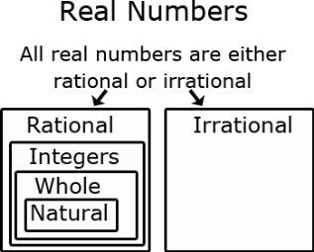  8.NS.2. Students can approximate square roots by iterative processes.  Examples:  • Approximate the value of √5 to the nearest hundredth.  Solution: Students start with a rough estimate based upon perfect squares. √5 falls between 2 and 3 because 5 falls between 2² = 4 and 3² = 9. The value will be closer to 2 than to 3. Students continue the iterative process with the tenths place value. √5 falls between 2.2 and 2.3 because 5 falls between 2.2² = 4.84 and 2.3² = 5.29. The value is closer to 2.2. Further iteration shows that the value of √5 is between 2.23 and 2.24 since 2.23² is 4.9729 and 2.24² is 5.0176.  • Compare √2 and √3 by estimating their values, plotting them on a number line, and making comparative statements.  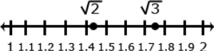  Solution: Statements for the comparison could include:  √2 is approximately 0.3 less than √3  √2 is between the whole numbers 1 and 2  √3 is between 1.7 and 1.8
8.EE.3. Use numbers expressed in the form of a single digit times an integer power of 10 to estimate very large or very small quantities, and to express how many times as much one is than the other. For example, estimate the population of the United States as 3 × 10⁸ and the population of the world as 7 × 10⁹, and determine that the world population is more than 20 times larger.  8.EE.1. Know and apply the properties of integer exponents to generate equivalent numerical expressions. For example, 3² × 3^{–5} = 3^{–3} = 1/3³ = 1/27.  8.EE.2 Use square root and cube root symbols to represent solutions to equations of the form x² = p and x³ = p, where p is a positive rational number. Evaluate square roots of small perfect squares and cube roots of small perfect cubes. Know that √2 is irrational. | 8.EE.1. Examples:  - =  - = 4³⁻⁷ = 4⁻⁴ =  - = 4⁻³ × = = =  8.EE.2 Examples:  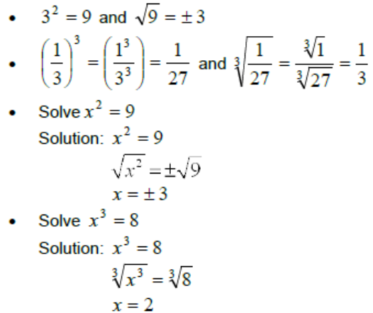
8.EE.4. Perform operations with numbers expressed in scientific notation, including problems where both decimal and scientific notation are used. Use scientific notation and choose units of appropriate size for measurements of very large or very small quantities (e.g., use millimeters per year for seafloor spreading). Interpret scientific notation that has been generated by technology. | 8.EE.4.  Students can convert decimal forms to scientific notation and apply rules of exponents to simplify expressions. In working with calculators or spreadsheets, it is important that students recognize scientific notation. Students should recognize that the output of 2.45E+23 is 2.45 x 10²³ and 3.5E-4 is 3.5 x 10⁻⁴. Students enter scientific notation using E or EE (scientific notation), * (multiplication), and ^ (exponent) symbols.

Concepts  What Students Need to Know | Skills  What Students Need To Be Able To Do | Bloom’s Taxonomy Levels
- Rational number  - Irrational number  - Decimal expansion  - Integer power of 10  - Scientific notation  - Properties of integer exponents  - Square root  - Perfect square  - Cube root  - Perfect cube | - KNOW (rational and irrational numbers)  - UNDERSTAND (decimal expansion)  - SHOW (decimal expansion repeats)  - CONVERT (repeating decimal expansion to a rational number)  - USE  - (integer power of 10)  - ESTIMATE (large or small quantities)  - EXPRESS (magnitude of numbers using powers of 10)  - (rational approximations of irrational numbers)  - COMPARE (sizes of rational numbers)  - LOCATE (rational numbers approximately on a number line)  - ESTIMATE (value of expressions)  - (square root and cube root symbols)  - REPRESENT (solutions to equations)  - (scientific notation)  - REPRESENT (very large and very small numbers)  - CHOOSE (units of appropriate size)  - EVALUATE  - (square roots of perfect squares)  - (cube roots of perfect cubes)  - KNOW/APPLY (properties of integer exponents)  - GENERATE (equivalent numerical expressions)  - CALCULATE/CONVERT (numbers expressed in scientific notation/decimal form)  - INTERPRET(scientific notation generated by technology) | 2  2  2  3  3  3  2  3  1  2  2  2  2  3  1,3  3  3  4

Essential Questions

Corresponding Big Ideas

Standardized Assessment Correlations
(State, College and Career)
Expectations for Learning (in development)
This information will be included as it is developed at the national level. CT is a governing member of the Smarter Balanced Assessment Consortium (SBAC) and has input into the development of the assessment.

Tasks
These tasks can be used during the course of instruction when deemed appropriate by the teacher.
“Ponzi” Pyramid Schemes
http://map.mathshell.org/materials/tasks.php?taskid=278&subpage=expert

Giantburgers
http://map.mathshell.org/materials/tasks.php?taskid=266#task266
Source: Mathematics Assessment Project (Shell Center/MARS, University of Nottingham & UC Berkeley)

Unit Assessments
The items developed for this section can be used during the course of instruction when deemed appropriate by the teacher.
- Which number is an irrational number?

A) 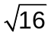 B) 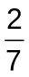 C) 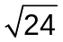* D) 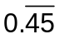

- Which number below is an irrational number?

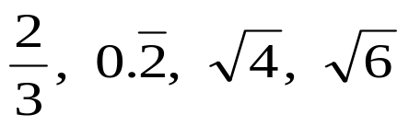
Show or explain how you know determined your answer.
Answer: 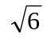 with an explanation that may include:
- When converting to a decimal, is a non-repeating, non-terminating decimal
- 6 is not a perfect square, therefore, cannot be simplified to a rational number

Partial Credit: Correct answer,, with an incorrect or missing explanation, OR an incorrect answer with an explanation that demonstrates understanding of the definition of an irrational number.

No Credit: Incorrect answer with an incorrect or missing explanation.

- Look at the following numbers.
11 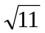 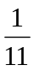 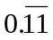 0.12345678…
Write the numbers in the table below.
Rational Numbers | Irrational Numbers

Answer:
Rational Numbers | Irrational Numbers
11 | 0.12345678…

- What fraction is equivalent to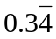? Show or explain how you found your answer.
Answer: 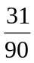 with an explanation describing the method the student used to find the answer, for example:
10 X = 3.4444
- X = 0.34444
9 X = 3.1
X =
Partial Credit: Correct answer,, with an incorrect or missing explanation, OR an incorrect answer with an explanation that demonstrates understanding of expressing a repeating decimal as a fraction.

No Credit: Incorrect answer with an incorrect or missing explanation.

- Which fraction is equivalent to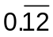?

A) 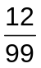* B) 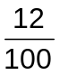 C) 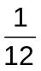 D) 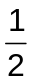

- Write in decimal form? Show or explain how you found your answer.
Answer: 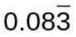or 0.083…. with an explanation describing the method used to find the answer, for example, dividing 12 by 1 and noting that the 3 repeats.

Partial Credit: Correct answer, 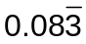or 0.083…., with an incorrect or missing explanation, OR an incorrect answer with an explanation that demonstrates understanding of expressing fraction as a repeating decimal.

No Credit: Incorrect answer with an incorrect or missing explanation.

- Mark an X on the number line that best represents the location of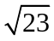.
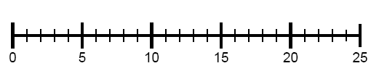

Answer: The student marks an X near the point on the number line that represents 4.8.
X

- On a test, Tracey was asked to plot 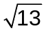on a number line. She drew the following diagram:
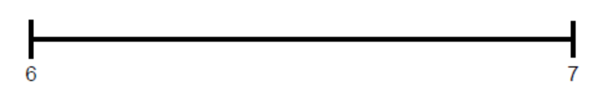
Did Tracey correctly plot on the number line? Show or explain how you found your answer.
Answer: No, Tracey did not correctly ploton the number line with an explanation that indicates that the square root is approximately 3.6, and would be located between 3 and 4 on a number line.

Partial Credit: Correct answer, No, with an incorrect or missing explanation, OR an incorrect answer with an explanation that demonstrates understanding of correctly expressing as a decimal number.

No Credit: Incorrect answer with an incorrect or missing explanation.

- Which list shows the numbers in order from least to greatest?

A) 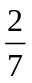, 1.7, 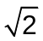

B) , , 1.7 *

C) , , 1.7

D) 1.7, ,

- Simplify:
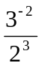
Show your work or explain how you found your answer.
Answer: 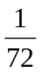with an explanation such as, 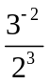 = =
Partial Credit: Correct answer,, with an incorrect or missing explanation, OR an incorrect answer with an explanation that demonstrates understanding of simplifying .

No Credit: Incorrect answer with an incorrect or missing explanation.

- 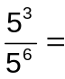

Answer: 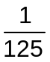

- 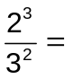

Answer: 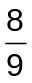
- 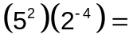

Answer: 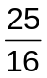

- 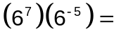

Answer: 36
- 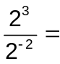

Answer: 32

- 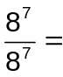

Answer: 1
- 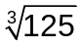=

Answer: 5

- 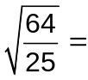

Answer: 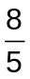

- Solve the equation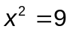.

Show or explain how you found your answer.

Answer: 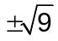 or 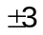with an explanation demonstrating understanding of solving a problem that has a squared variable by finding the square root of both sides of the equation. Explanation may include, (3)(3) = 9 AND 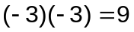
Partial Credit: Correct answer, or , with an incorrect or missing explanation, OR an incorrect answer with an explanation that demonstrates understanding of solving a problem that has a squared variable by finding the square root of both sides of the equation.

No Credit: Incorrect answer with an incorrect or missing explanation.

- A square picture frame has an area of 64 square inches. What is the length of each side of the picture frame?
Show your work or explain your answer.
Answer: 8 inches, with an explanation that demonstrates understanding that area of a square can be found using the formula
a = s², therefore, 64 = s² and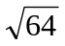 = 8 inches, or student explains that a square has equal sides and since (8)(8) = 64, the side length is 8 inches.

Partial Credit: Correct answer, 8 inches, with an incorrect or missing explanation, OR an incorrect answer with an explanation that demonstrates understanding of finding the length of a side of a square given the area or solving the equation 64 = s².

No Credit: Incorrect answer with an incorrect or missing explanation.
- A cube has a volume of 27 cubic centimeters. What is the length of each edge of the cube?
Show or explain how you found your answer.
Answer: 3 centimeters with an explanation that demonstrates understanding that the volume of a cube can be found using the formula
V = e³, therefore, 27 = e³ and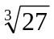 = 3 cm, or student explains that a cube has equal edges and since (3)(3)(3) = 27, the edge length is 3 inches.

Partial Credit: Correct answer, 3 centimeters, with an incorrect or missing explanation, OR an incorrect answer with an explanation that demonstrates understanding of finding the edge of a cube of a cube given the volume or solving the equation 27 = e³.

No Credit: Incorrect answer with an incorrect or missing explanation.
- The mass of Neptune is about 1 x 10²⁶ kilograms. The mass of Jupiter is about 2 x 10²⁷ kilograms. Approximately how many times heavier is Jupiter than Neptune?

Answer: 20

- 3 x 10⁻⁵ is how many times larger than 1 x 10⁻⁷?

Answer: 300

- In November 2010, the population of China was 1,339,724,852 people. Which number is closest to this population?
A) 1 × 10⁷ B) 1 × 10⁸ C) 1 × 10⁹* D) 1 × 10¹⁰

- 4 x 10⁸ is how many times larger than 2 x 10⁵?
Show or explain how you found your answer.
Answer: 2,000 with an explanation that may include:
- finding the quotient of 4 x 10⁸ and 2 x 10⁵ or the quotient of 400,000,000 and 200,000
- finding the quotient of 4 ÷ 2 and 10⁸ ÷ 10⁵ = 2 x 10³ = 2000.
Partial Credit: Correct answer, 2,000, with an incorrect or missing explanation, OR an incorrect answer with an explanation that demonstrates understanding of solving a problem with scientific notation.

No Credit: Incorrect answer with an incorrect or missing explanation.

- (0.00002) (3 x 10⁸) =

Answer: 6,000

- 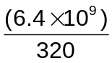=

Answer: 2 × 10⁷

- 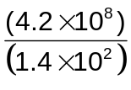=

Answer: 3 × 10⁶

- 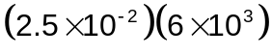=

Answer 150
- The population of Japan in 2009 was approximately 1.3 x 10⁸ people. The area of Japan is approximately 142,000 square miles. What was the population density (number of people per square mile) in 2009?
Answer: ≈ 915.5 with an explanation that may include:
- finding the quotient of 1.3 x 10⁸ and 142,000 by dividing 130,000,000 and 142,000
- finding the quotient of 1.3 ÷ 1.42 and 10⁸ ÷ 10⁵ ≈ 0.91549 x 10³ ≈ 915.5.
Partial Credit: Correct answer, ≈ 915.5, with an incorrect or missing explanation, OR an incorrect answer with an explanation that demonstrates understanding of solving a problem with scientific notation.

No Credit: Incorrect answer with an incorrect or missing explanation.
- The projected population of Hawaii in 2020 is about 5.48 x 2¹⁸. The land area of Hawaii is about 2¹⁴ square kilometers. Predict the average number of people per square kilometer in 2020.
Show or explain how you found your answer.
Answer: ≈ 87.68 with an explanation that may include.
- The student simplified the exponents and then multiplied by 5.48.

Pacing: 4 weeks (plus 1 week for reteaching/enrichment)
Mathematical Practices
Mathematical Practices #1 and #3 describe a classroom environment that encourages thinking mathematically and are critical for quality teaching and learning.

Practices in bold are to be emphasized in the unit.
1. Make sense of problems and persevere in solving them.
2. Reason abstractly and quantitatively.
3. Construct viable arguments and critique the reasoning of others.
4. Model with mathematics.
5. Use appropriate tools strategically.
6. Attend to precision.
7. Look for and make use of structure.
8. Look for and express regularity in repeated reasoning.

Domain and Standards Overview
Geometry
- Understand and apply the Pythagorean Theorem.
- Work with radicals and integer exponents.

Priority and Supporting CCSS | Explanations and Examples*
8.G.7. Apply the Pythagorean Theorem to determine unknown side lengths in right triangles in real-world and mathematical problems in two and three dimensions.  8.G.6. Explain a proof of the Pythagorean Theorem and its converse.  8.G.8. Apply the Pythagorean Theorem to find the distance between two points in a coordinate system.  8.EE.2. Use square root and cube root symbols to represent solutions to equations of the form x² = p and x³ = p, where p is a positive rational number. Evaluate square roots of small perfect squares and cube roots of small perfect cubes. Know that √2 is irrational. | 8.G.7. Through authentic experiences and exploration, students should use the Pythagorean Theorem to solve problems. Problems can include working in both two and three dimensions. Students should be familiar with the common Pythagorean triplets.  8.G.6. Students should verify, using a model, that the sum of the squares of the legs is equal to the square of the hypotenuse in a right triangle. Students should also understand that if the sum of the squares of the 2 smaller legs of a triangle is equal to the square of the third leg, then the triangle is a right triangle.  8.G.8. Example:  • Students will create a right triangle from the two points given (as shown in the diagram below) and then use the Pythagorean Theorem to find the distance between the two given points.  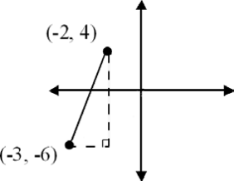  8.EE.2. Examples:

Concepts  What Students Need to Know | Skills  What Students Need To Be Able To Do | Bloom’s Taxonomy Levels
- Pythagorean Theorem  - Proof of and its converse  - Right triangles  - Coordinate system  - Square root  - Perfect square  - Cube root  - Perfect cube | - APPLY (Pythagorean Theorem)  - DETERMINE (unknown side lengths in right triangles)  - FIND (distance between two points in a coordinate system)  - EXPLAIN (a proof of the Pythagorean Theorem and its converse)  - USE  - (square root and cube root symbols)  - REPRESENT (solutions to equations)  - EVALUATE  - (square roots of perfect squares)  - (cube roots of perfect cubes) | 3  3  1  4  2  2  3

Essential Questions

Corresponding Big Ideas

Standardized Assessment Correlations
(State, College and Career)
Expectations for Learning (in development)
This information will be included as it is developed at the national level. CT is a governing member of the Smarter Balanced Assessment Consortium (SBAC) and has input into the development of the assessment.

Unit Assessments
The items developed for this section can be used during the course of instruction when deemed appropriate by the teacher.

Pacing: 3 weeks (plus 1 week for reteaching/enrichment)
Mathematical Practices
Mathematical Practices #1 and #3 describe a classroom environment that encourages thinking mathematically and are critical for quality teaching and learning.

Practices in bold are to be emphasized in the unit.
1. Make sense of problems and persevere in solving them.
2. Reason abstractly and quantitatively.
3. Construct viable arguments and critique the reasoning of others.
4. Model with mathematics.
5. Use appropriate tools strategically.
6. Attend to precision.
7. Look for and make use of structure.
8. Look for and express regularity in repeated reasoning.

Domain and Standards Overview
Geometry
- Understand congruence and similarity using physical models, transparencies, or geometry software.

Priority and Supporting CCSS | Explanations and Examples*
8.G.2. Understand that a two-dimensional figure is congruent to another if the second can be obtained from the first by a sequence of rotations, reflections and translations; given two congruent figures, describe a sequence that exhibits the congruence between them.  8.G.1 Verify experimentally the properties of rotations, reflections, and translations:  - Lines are taken to lines, and line segments to line segments of the same length.  - Angles are taken to angles of the same measure.  - Parallel lines are taken to parallel lines. | 8.G.2. Examples:  • Is Figure A congruent to Figure A’? Explain how you know.  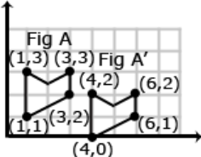  • Describe the sequence of transformations that results in the transformation of Figure A to Figure A’.  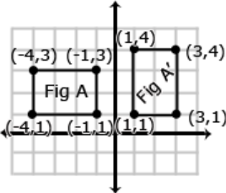  8.G.1 Students need multiple opportunities to explore the transformation of figures so that they can appreciate that points stay the same distance apart and lines stay at the same angle after they have been rotated, reflected, and/or translated.  Students are not expected to work formally with properties of dilations until high school.
8.G.4. Understand that a two-dimensional figure is similar to another if the second can be obtained from the first by a sequence of rotations, reflections, translations, and dilations; given two similar two-dimensional figures, describe a sequence that exhibits the similarity between them.  8.G.3. Describe the effect of dilations, translations, rotations, and reflections on two-dimensional figures using coordinates. | 8.G.4. Examples:  • Is Figure A similar to Figure A’? Explain how you know.  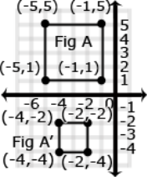  • Describe the sequence of transformations that results in the transformation of Figure A to Figure A’.  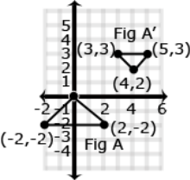  8.G.3.  Dilation: A dilation is a transformation that moves each point along a ray emanating from a fixed center, and multiplies distances from the center by a common scale factor. In dilated figures, the dilated figure is similar to its pre-image.  Translation: A translation is a transformation of an object that moves the object so that every point of the object moves in the same direction as well as the same distance. In a translation, the translated object is congruent to its pre-image. ΔABC has been translated 7 units to the right and 3 units up. To get from A (1,5) to A’ (8,8), move A 7 units to the right (from x = 1 to x = 8) and 3 units up (from y = 5 to y = 8). Points B + C also move in the same direction (7 units to the right and 3 units up).  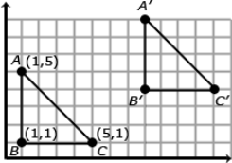 (Continued on next page)
Reflection: A reflection is a transformation that flips an object across a line of reflection (in a coordinate grid the line of reflection may be the x or y axis). In a rotation, the rotated object is congruent to its pre-image.

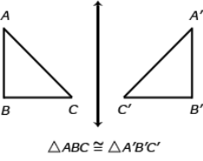

When an object is reflected across the y axis, the reflected x coordinate is the opposite of the pre-image x coordinate.
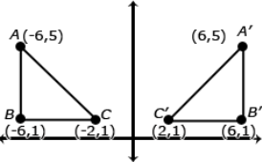

Rotation: A rotated figure is a figure that has been turned about a fixed point. This is called the center of rotation. A figure can be rotated up to 360˚. Rotated figures are congruent to their pre-image figures.

Consider when ΔDEF is rotated 180˚ clockwise about the origin. The coordinates of ΔDEF are D(2,5), E(2,1), and F(8,1). When rotated 180˚, ΔD’E’F’ has new coordinates D’(-2,-5), E’(-2,-1) and F’(-8,-1). Each coordinate is the opposite of its pre-image.
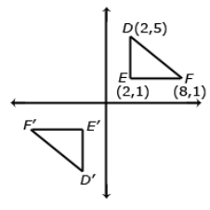

8.G.5. Use informal arguments to establish facts about the angle sum and exterior angle of triangles, about the angles created when parallel lines are cut by a transversal, and the angle-angle criterion for similarity of triangles. For example, arrange three copies of the same triangle so that the sum of the three angles appears to form a line, and give an argument in terms of transversals why this is so. | 8.G.5. Examples: Students can informally prove relationships with transversals.  Show that m∡3+ m∡4+ m∡5= 180˚ if land m are parallel lines and t₁ & t₂ are transversals.  ∡1+ ∡2+ ∡3= 180˚. Angle and Angle 5 are congruent because they are corresponding angles (∡5≅∡1). ∡1can be substituted for ∡5.  ∡4≅∡2 : because alternate interior angles are congruent. ∡4can be substituted for ∡2  Therefore m∡3+ m∡4+ m∡5= 180˚  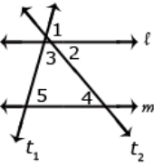  Students can informally conclude that the sum of a triangle is 180º (the angle-sum theorem) by applying their understanding of lines and alternate interior angles. In the figure below, line x is parallel to line yz:  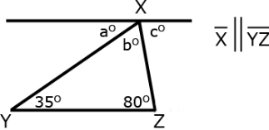  Angle a is 35º because it alternates with the angle inside the triangle that measures 35º. Angle c is 80º because it alternates with the angle inside the triangle that measures 80º. Because lines have a measure of 180º, and angles a + b + c form a straight line, then angle b must be 65 º (180 – 35 + 80 = 65). Therefore, the sum of the angles of the triangle are 35º + 65 º + 80 º

Concepts  What Students Need to Know | Skills  What Students Need To Be Able To Do | Bloom’s Taxonomy Levels
- Rotation  - Reflection  - Translation  - Dilation  - Congruence  - Similarity  - Informal proof  - Angle sum and exterior angle of triangles  - Parallel lines cut by a transversal  - Angles formed  - Angle-angle criterion for similar triangles | - VERIFY (Experimentally properties of)  - Rotations  - Reflections  - Translations  - Dilations  - UNDERSTAND (Congruence)  - DESCRIBE (Sequence of rotations, reflections, translations)  - UNDERSTAND (Similarity)  - DESCRIBE (Sequence of rotations, reflections, translations, dilations)  - DESCRIBE (effect of dilations, translations, rotations and reflections using coordinates)  - PROVE (informally)  - angle relationships in parallel lines cut by a transversal  - sum of angles in a triangle = 180° | 2  2,3  2,3  2  5

Essential Questions

Corresponding Big Ideas

Standardized Assessment Correlations
(State, College and Career)
Expectations for Learning (in development)
This information will be included as it is developed at the national level. CT is a governing member of the Smarter Balanced Assessment Consortium (SBAC) and has input into the development of the assessment.

Unit Assessments
The items developed for this section can be used during the course of instruction when deemed appropriate by the teacher.

Pacing: 5 weeks (plus 1 week for reteaching/enrichment)
Mathematical Practices
Mathematical Practices #1 and #3 describe a classroom environment that encourages thinking mathematically and are critical for quality teaching and learning.

Practices in bold are to be emphasized in the unit.
1. Make sense of problems and persevere in solving them.
2. Reason abstractly and quantitatively.
3. Construct viable arguments and critique the reasoning of others.
4. Model with mathematics.
5. Use appropriate tools strategically.
6. Attend to precision.
7. Look for and make use of structure.
8. Look for and express regularity in repeated reasoning.

Domain and Standards Overview
Expressions and Equations
- Understand the connections between proportional relationships, lines, and linear equations.
- Analyze and solve linear equations
Functions
- Define, evaluate, and compare functions.
- Use functions to model relationships between quantities.

Priority and Supporting CCSS | Explanations and Examples*
8.EE.5. Graph proportional relationships, interpreting the unit rate as the slope of the graph. Compare two different proportional relationships represented in different ways. For example, compare a distance-time graph to a distance-time equation to determine which of two moving objects has greater speed.  8.EE.6. Use similar triangles to explain why the slope m is the same between any two distinct points on a non-vertical line in the coordinate plane; derive the equation y = mx for a line through the origin and the equation y = mx + b for a line intercepting the vertical axis at b.. | 8. EE.5. Using graphs of experiences that are familiar to students increases accessibility and supports understanding and interpretation of proportional relationship. Students are expected to both sketch and interpret graphs.  Example:  • Compare the scenarios to determine which represents a greater speed. Include a description of each scenario including the unit rates in your explanation.  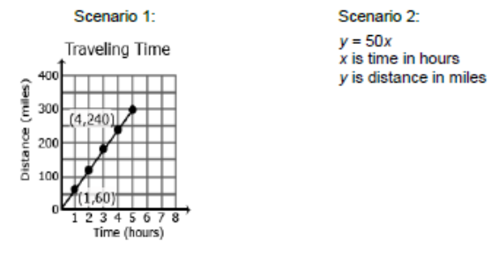  8.EE.6. Example:  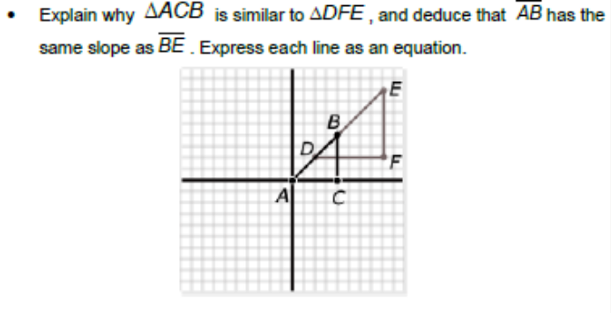
8.EE.7. Solve linear equations in one variable.  - Give examples of linear equations in one variable with one solution, infinitely many solutions, or no solutions. Show which of these possibilities is the case by successively transforming the given equation into simpler forms, until an equivalent equation of the form x = a, a = a, or a = b results (where a and b are different numbers).  - Solve linear equations with rational number coefficients, including equations whose solutions require expanding expressions using the distributive property and collecting like terms.  8.F.2. Compare properties of two functions each represented in a different way (algebraically, graphically, numerically in tables, or by verbal descriptions). For example, given a linear function represented by a table of values and a linear function represented by an algebraic expression, determine which function has the greater rate of change. | 8.EE.7. As students transform linear equations in one variable into simpler forms, they discover the equations can have one solution, infinitely many solutions, or no solutions.  When the equation has one solution, the variable has one value that makes the equation true as in  12 - 4y =16. The only value for y that makes this equation true is -1.  When the equation has infinitely many solutions, the equation is true for all real numbers as in  7x + 14 = 7(x+2). As this equation is simplified, the variable terms cancel leaving 14 = 14 or 0 = 0. Since the expressions are equivalent, the value for the two sides of the equation will be the same regardless which real number is used for the substitution.  When an equation has no solutions it is also called an inconsistent equation. This is the case when the two expressions are not equivalent as in 5x - 2 = 5(x+1). When simplifying this equation, students will find that the solution appears to be two numbers that are not equal or -2 = 1. In this case, regardless which real number is used for the substitution, the equation is not true and therefore has no solution.  Examples:  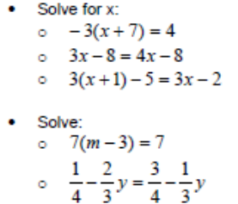  8.F.2. Examples:  - Compare the two linear functions listed below and determine which equation represents a greater rate of change.  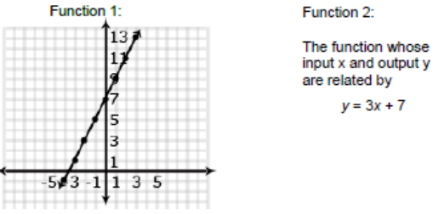(Continued on next page)
8.F.1. Understand that a function is a rule that assigns to each input exactly one output. The graph of a function is the set of ordered pairs consisting of an input and the corresponding output.  8.F.3.Interpret the equation y = mx + b as defining a linear function, whose graph is a straight line; give examples of functions that are not linear. For example, the function A = s² giving the area of a square as a function of its side length is not linear because its graph contains the points (1,1), (2,4) and (3,9), which are not on a straight line. | - Compare the two linear functions listed below and determine which has a negative slope.  Function 1: Gift Card  Samantha starts with $20 on a gift card for the book store. She spends $3.50 per week to buy a magazine. Let y be the amount remaining as a function of the number of weeks.  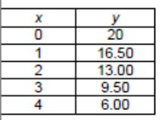  Function 2:  The school bookstore rents graphing calculators for $5 per month. It also collects a non-refundable fee of $10.00 for the school year. Write the rule for the total cost (c) of renting a calculator as a function of the number of months (m).  Solution:  Function 1 is an example of a function whose graph has negative slope. Samantha starts with $20 and spends money each week. The amount of money left on the gift card decreases each week. The graph has a negative slope of -3.5, which is the amount the gift card balance decreases with Samantha’s weekly magazine purchase. Function 2 is an example of a function whose graph has positive slope. Students pay a yearly nonrefundable fee for renting the calculator and pay $5 for each month they rent the calculator. This function has a positive slope of 5 which is the amount of the monthly rental fee. An equation for Example 2 could be c = 5m + 10.  8.F.1. For example, the rule that takes x as input and gives x²+5x+4 as output is a function. Using y to stand for the output we can represent this function with the equation y = x²+5x+4, and the graph of the equation is the graph of the function. Students are not yet expected use function notation such as f(x) = x²+5x+4.  8.F.3. Example:  • Determine which of the functions listed below are linear and which are not linear and explain your reasoning.  o y = -2x² + 3 non linear  o y = 2x linear  o A = πr² non linear  o y = 0.25 + 0.5(x – 2) linear
8.F.4. Construct a function to model a linear relationship between two quantities. Determine the rate of change and initial value of the function from a description of a relationship or from two (x, y) values, including reading these from a table or from a graph. Interpret the rate of change and initial value of a linear function in terms of the situation it models, and in terms of its graph or a table of values.  8.F.5.Describe qualitatively the functional relationship between two quantities by analyzing a graph, (e.g. where the function is increasing or decreasing, linear or nonlinear). Sketch a graph that exhibits the qualitative features of a function that has been described verbally. | 8.F.4. Examples:  • The table below shows the cost of renting a car. The company charges $45 a day for the car as well as charging a one-time $25 fee for the car’s navigation system (GPS).Write an expression for the cost in dollars, c, as a function of the number of days, d.  Students might write the equation c = 45d + 25 using the verbal description or by first making a table.  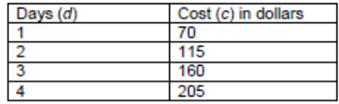  Students should recognize that the rate of change is 45 (the cost of renting the car) and that initial cost (the first day charge) also includes paying for the navigation system. Classroom discussion about one time fees vs. recurrent fees will help students model contextual situations.  • When scuba divers come back to the surface of the water, they need to be careful not to ascend too quickly. Divers should not come to the surface more quickly than a rate of 0.75 ft per second. If the divers start at a depth of 100 feet, the equation d = 0.75t – 100 shows the relationship between the time of the ascent in seconds (t) and the distance from the surface in feet (d).  o Will they be at the surface in 5 minutes? How long will it take the divers to surface from their dive?  • Make a table of values showing several times and the corresponding distance of the divers from the surface. Explain what your table shows. How do the values in the table relate to your equation?  8.F.5. Example:  • The graph below shows a student’s trip to school. This student walks to his friend’s house and, together, they ride a bus to school. The bus stops once before arriving at school.  Describe how each part A-E of the graph relates to the story.  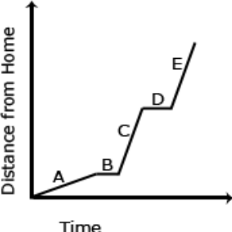

Concepts  What Students Need to Know | Skills  What Students Need To Be Able To Do | Bloom’s Taxonomy Levels
- Proportional relationships  - Unit rate  - Slope (m)  - Y-intercept (b)  - Linear equations (y = mx and y = mx + b)  - Rational Number Coefficients  - One variable  - One solution  - Infinitely many solutions  - No solutions  - Equations into simple forms  - Expanding Expressions  - Distributive property  - Combining Like terms  - Functions  - Properties  - Linear  - Non-linear  - Input/Output  - Ordered pairs  - Linear/functional relationship  - rate of change  - initial value (function)  - table  - graph  - Similar triangles | - GRAPH (proportional relationships)  - INTERPRET (unit rate as slope)  - COMPARE (proportional relationships)  - EXPLAIN (why slope is the same between any two points on a non-vertical line)  - DERIVE (linear equations (y = mx and y = mx + b)  - SOLVE (linear equations)  - GIVE (example of linear equations)  - TRANSFORM (equations)  - EXPAND (expressions)  - Use (distributive property)  - Collect (like terms)  - UNDERSTAND (function is a rule)  - GRAPH (sets of ordered pairs)  - COMPARE (functions)  - Algebraically  - Graphically  - Numerically in tables  - Verbal descriptions  - CONSTRUCT (function)  - Model (linear relationship)  - DETERMINE (rate of change and initial value of function)  - READ (table or graph)  - INTERPRET  - y = mx + b  - rate of change and initial value of function  - GIVE (examples of non-linear functions)  - DESCRIBE (functional relationship between two quantities)  - DRAW (graph from a verbal description) | 4  2  2  3  3  3  2  3  3  2  3  3  2  2  3  2  2

Essential Questions

Corresponding Big Ideas

Standardized Assessment Correlations
(State, College and Career)
Expectations for Learning (in development)
This information will be included as it is developed at the national level. CT is a governing member of the Smarter Balanced Assessment Consortium (SBAC) and has input into the development of the assessment.

Tasks
These tasks can be used during the course of instruction when deemed appropriate by the teacher.
- Multiple Solutions task. Students are given various equations and inequalities and are asked to find 2 sample solutions to each. Next, students identify whether the equation/inequality falls into the category of: exactly 2 solutions, more than 2 solutions, but not infinitely many solutions, or infinitely many solutions. The task ties into several standards, including those from Number Systems and Expressions and Equations, and may be best used formatively to assess student understanding of prerequisite knowledge.

http://map.mathshell.org/materials/tasks.php?taskid=263&subpage=apprentice

Source: Mathematics Assessment Project (Shell Center/MARS, University of Nottingham & UC Berkeley)
- Interpreting Distance-Time Graphs
http://map.mathshell.org/materials/lessons.php?taskid=208
This is a lesson that can be used formatively.

Unit Assessments
The items developed for this section can be used during the course of instruction when deemed appropriate by the teacher.
- Which scenario represents a greater speed. Write a description of each scenario including the unit rates in your explanation.

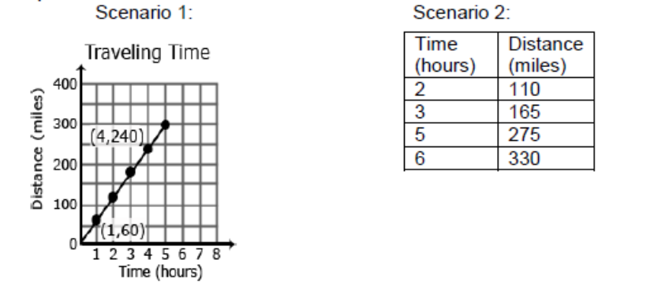
Show or explain how you found your answer.

Answer: Scenario 1 represents a greater speed with an explanation that may include:
- The unit rate (slope) of scenario 1 is 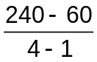 = 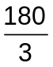 = 60 mph
- The unit rate (slope) of scenario 2 is 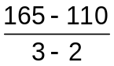 = 55 mph

Partial Credit: Correct answer, Scenario 1, with an incorrect or missing explanation, OR an incorrect answer with an explanation that demonstrates understanding of finding unit rate/slope.

No Credit: Incorrect answer with an incorrect or missing explanation.

- The graph below shows the cost to wash a car at Euclid’s Car Wash.
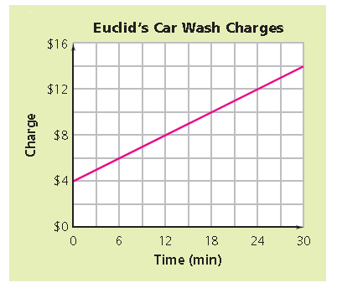
What is the slope of the line? Describe what the graph and slope of the line tell you about the cost to wash a car at Euclid’s car wash? Show or explain how you found your answer.
Answer: Slope = 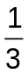 with an explanation that may include:
- The unit rate (slope) of the line is 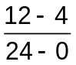 = 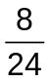 = , which means that the cost is $1 for every 3 minutes. The graph of the line shows that the cost to wash a car is $4 plus $1 for every 3 minutes of car washing.
Partial Credit: Correct answer, Slope = , with an incorrect or missing explanation, OR an incorrect answer with an explanation that demonstrates understanding of finding unit rate/slope and a correct interpretation of what the graph of the line shows about the cost of a car wash.
No Credit: Incorrect answer with an incorrect or missing explanation.
Source: Thinking with Mathematical Models, Connected Math Program
- The equation below shows the total profit, p, from a school dance. The number of tickets sold is represented by x and the amount paid to the DJ was $600.
p = 8x - 600
What does the 8 represent in the equation?
Answer: The price of each ticket.

- Look at the triangles in the graph below. Sides a and d lie along the same line.
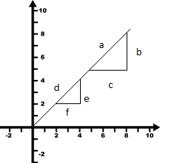
How are the triangles related to each other? Show or explain how you found your answer. (Source: Thinking with Mathematical Models, Connected Mathematics 2)

Answer: The triangles are similar with an explanation that may include:
- Since sides a and d lie on the same line, the slope of the sides are the same. Therefore the ratio of b/c and e/f must be proportional.

Partial Credit: Correct answer with an incorrect or missing explanation OR and incorrect answer with an explanation that demonstrates understanding that the triangles are proportional because the hypotenuse of each triangle lies along the same line, making the sides proportional.

No Credit: Incorrect answer with an incorrect or missing explanation.
- Look at the graph below.
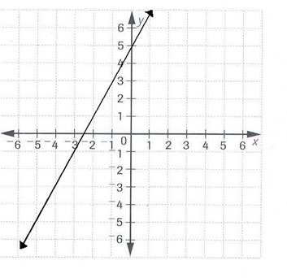
What is the equation of the line shown in the graph?
Answer: y = 2x + 5

- The graph below shows the amount of money earned and the number of weeks worked for Jonah (top/blue line) and Tracey (bottom/pink line).
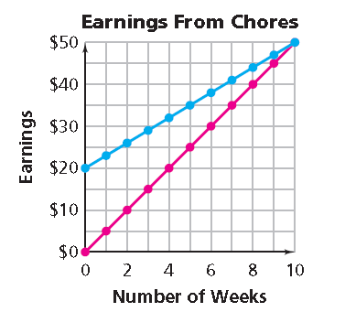
- Write a linear equation for each line in the form y = mx + b. (Source: Thinking with Mathematical Models, Connected Mathematics 2)
Answer: Top/Blue line (Jonah) y = 3x + 20
Bottom/Pink line (Tracey) y = 5x

- What is the y-intercept of each line? What does each y-intercept value represent in this situation?
Answer: Top/Blue line (Jonah) y-intercept = 20, with an explanation that may include that Jonah had $20 before he started earning money for chores. Bottom/Pink line (Tracey) y-intercept = 0, with an explanation that may include that Tracey had no money when she started earning money for chores.

- What is the slope of each line? What does the slope of each line represent in this situation?
Answer: Top/Blue line (Jonah) slope = 3, with an explanation that may include that Jonah earned $3 per week Bottom/Pink line (Tracey) y-intercept = 0, with an explanation that may include that Tracey had no money when she started earning money for chores.

- Look at the graph below.
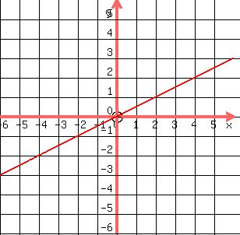
What is the equation of the line shown in the graph?
Answer: y = ½x or y = 0.5x (or any equivalent equation)

- Look at the equation below.
2w + 21 = 5w – 3w + 21
Does the equation have one solution, no solution or an infinite number of solutions? Show or explain how you found your answer

Answer: Infinite number of solutions with an explanation that may include:
- Simplifying the equation to 21 = 21, which is a true statement, therefore, any number substituted for w will result in a true statement
- 2w + 21 equals 2w + 21, therefore any number substituted for w will result in a true statement

Partial Credit: Correct answer with an incorrect or missing explanation, OR an incorrect answer with an explanation that proves that there is an infinite number of solutions to the problem

No Credit: Incorrect answer with an incorrect or missing explanation.
- Look at the equation below.
9k + 1 = 4k – 1 + 5k
Does the equation have one solution, no solution or an infinite number of solutions? Show or explain how you found your answer

Answer: No Solutions with an explanation that may include:
- Simplifying the equation to 2 = 0, which is not true
- 9k + 1 does not equal 9k – 1

Partial Credit: Correct answer with an incorrect or missing explanation, OR an incorrect answer with an explanation that proves that there is no solution to the problem

No Credit: Incorrect answer with an incorrect or missing explanation.
- Solve the equation for x.
3x + 52 = 82
Answer: x = 10
- Solve the equation for x.
4 + 5(x + 2) = 7x
Answer: x = 7
- Solve the equation for x.
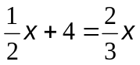
Answer: x = 24
- Solve the equation for x.
–5x – 35 = 5
Answer: –8

- Look at the table below.
x | y
0 | 5
1 | 7
1 | 8
3 | 9

Is this a function? Show or explain how you found your answer.
Answer: No, with an explanation that may include:
- A function can have only one x-value (input) for each y-value (output)
Partial Credit: Correct answer No, with an incorrect or missing explanation, OR an incorrect answer with an explanation that demonstrates understanding of the definition of a function.
No Credit: Incorrect answer with an incorrect or missing explanation.

- Look at the table below.
x | y
-1 | 1
0 | 0
1 | 1
2 | 4

Is this a function? Show or explain how you found your answer.
Answer: Yes, with an explanation that may include:
- A function can have more than one y-value (output) for each x-value (input)
- This table can be defined by the equation y = x² which is a function
Partial Credit: Correct answer Yes, with an incorrect or missing explanation, OR an incorrect answer with an explanation that demonstrates understanding of the definition of a function.
No Credit: Incorrect answer with an incorrect or missing explanation.

- Compare the two linear functions listed below.
Function 1 Function 2
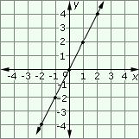
The function whose input x and output y are related by 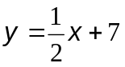

Which function represents a greater rate of change? Show or explain how you found your answer.
Answer: Function 1, with an explanation that may include:
- Function 1 has a slope (or rate of change) equal to 2 and Function 2 has a slope (or rate of change) equal to ½.

Partial Credit: Correct answer Function 1, with an incorrect or missing explanation, OR an incorrect answer with an explanation that demonstrates understanding of finding slope (or rate of change) of a linear function.
No Credit: Incorrect answer with an incorrect or missing explanation.

- Compare the two linear functions below.
Function 1 Function 2
x | y
0 | 20
1 | 16.5
2 | 13
3 | 9.5

Which linear function has a negative slope? Show or explain how you found your answer.
Answer: Function 2 with a correct explanation that may include:
- Function 1 has a slope of 2 and Function 2 has a slope of -3.5
- The line for Function 1 moves up and to the right in a positive direction and Function 2 has y-values that decrease as the x values increases resulting in a negative slope.

Partial Credit: Correct answer Function 2, with an incorrect or missing explanation, OR an incorrect answer with an explanation that demonstrates understanding of how to determine whether the slope (or rate of change) of a linear function is positive or negative.
No Credit: Incorrect answer with an incorrect or missing explanation.

- The text message plans of two different cell phone companies are shown below.
- Texstar, charges $0.04 per text message.
- Berizon, charges according to the table of prices below.
Berizon Text Message Charges
# of text messages | Price  ($)
0 - 100 | 5
101 - 200 | 10
201 - 300 | 15
301 - 400 | 20
401 - 500 | 25

Which cell phone company has the least expensive text message plan for up to 500 text messages? Show or explain how you found your answer.
Answer: Texstar, with an explanation that may include:
- The least expensive cost per text for Berizon is $0.05 per text. Texstar charges $0.04 per text.

Partial Credit: Correct answer Texstar, with an incorrect or missing explanation, OR an incorrect answer with an explanation that demonstrates understanding of how to determine which cell phone text message plan is the least expensive.

No Credit: Incorrect answer with an incorrect or missing explanation.
- Look at the equation below.
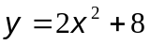
Does this equation represent a linear function or a non-linear function? Show or explain how you found your answer.
Answer: Non-linear function, with an explanation that may include:
- The equation is not of the form y = mx + b
- The equation includes an exponent on the variable, x (student may indicate that this is a quadratic equation)
- The graph of the equation is not a straight line which means that it is a non-linear function (student may indicate that the graph is a parabola)

Partial Credit: Correct answer Non-linear equation, with an incorrect or missing explanation, OR an incorrect answer with an explanation that demonstrates understanding of how to determine if a function is linear or non-linear.

No Credit: Incorrect answer with an incorrect or missing explanation.

- Classify each equation by writing linear function or non-linear function next to each. Show or explain how you found you determined your answers.
- y = -2x + 3 __________________________
- y = x² + 3x + 1 __________________________
- y = __________________________
- 4y + x = 3 __________________________
Answer: A. Linear Function
B. Non-Linear Function
C. Non-Linear Function
D. Linear Function
With an explanation that may include:
- A and D are linear functions because they can be written in the form y = mx + b, OR the graph of each equation is a straight line,
- B and C are non-linear functions because they cannot be written in the form y = mx + b, OR the graph of each equation is not a straight line

Partial Credit: Correct answer (see above), with an incorrect or missing explanation, OR an incorrect answer with an explanation that demonstrates understanding of the difference between a linear or non-linear function.

No Credit: Incorrect answer with an incorrect or missing explanation.

- A college bookstore rents graphing calculators for $5 per month. It also collects a non-refundable fee of $10 for the school year. Write an equation for the total cost (c) of renting a calculator as a function of the number of months (m)?
Answer: c = 5m + 10
- Mary walked from her home to the library. About half way to the library, she stopped to talk her friends. She then continued walking at a faster pace until she reached the library. Sketch a graph that shows the relationship between time and distance Mary walked.
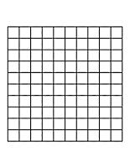
Answer: The horizontal axis is labeled “Time” and the vertical axis is labeled “Distance.” The first segment line should have a positive slope, followed by a horizontal segment (slope of 0), and followed by a segment that has a greater slope than the first segment.
To raise the depth of knowledge (DOK), ask students to provide an appropriate scale for each axis and explain why it is reasonable, including a reasonable walking speed related to the slope of the line.

- Look at the graph below.
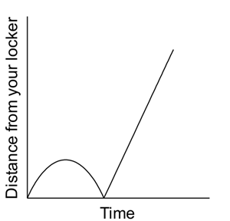
Describe a scenario that is illustrated by this graph.
Answer: The graph shows the relationship between the distance a student is from his/her locker over time. The description should include reasoning as to why the graph curves up and back down and then goes up at a constant rate. This may include:
- “I left my locker and started walking to class and then realized I forgot something and went back to my locker. I then walked at a constant pace to class.

Partial Credit: The description is incomplete or includes an incorrect interpretation of part of the graph.

No Credit: Incorrect or missing description.

- Which graph best represents a person’s distance from the ground while riding a Ferris wheel?
- * 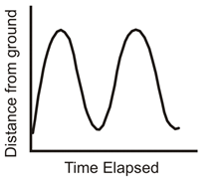 C. 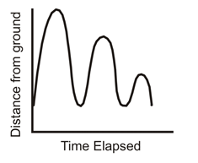

- 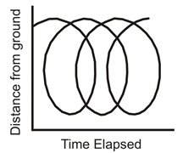 D. 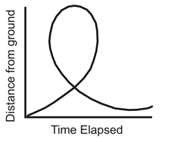

- The graph below shows a student’s trip to school. This student walks to his friend’s house and, together, they ride a bus to school. The bus stops once before arriving at school.

Which letter on the graph represents when the bus stopped?
Answer: D

Pacing: 4 weeks (plus 1 week for reteaching/enrichment)
Mathematical Practices
Mathematical Practices #1 and #3 describe a classroom environment that encourages thinking mathematically and are critical for quality teaching and learning.

Practices in bold are to be emphasized in the unit.
1. Make sense of problems and persevere in solving them.
2. Reason abstractly and quantitatively.
3. Construct viable arguments and critique the reasoning of others.
4. Model with mathematics.
5. Use appropriate tools strategically.
6. Attend to precision.
7. Look for and make use of structure.
8. Look for and express regularity in repeated reasoning.

Domain and Standards Overview
Expressions and Equations
- Analyze and solve linear equations and pairs of simultaneous linear equations.
Functions
- Use functions to model relationships between quantities.

Priority and Supporting CCSS | Explanations and Examples*
8.EE.8. Analyze and solve pairs of simultaneous linear equations.  a. Understand that solutions to a system of two linear equations in two variables correspond to points of intersection of their graphs, because points of intersection satisfy both equations simultaneously.  b. Solve systems of two linear equations in two variables algebraically, and estimate solutions by graphing the equations. Solve simple cases by inspection. For example, 3x + 2y = 5 and 3x + 2y = 6 have no solution because 3x + 2y cannot simultaneously be 5 and 6.  c. Solve real-world and mathematical problems leading to two linear equations in two variables. For example, given coordinates for two pairs of points, determine whether the line through the first pair of points intersects the line through the second pair. | 8.EE.8. Systems of linear equations can also have one solution, infinitely many solutions or no solutions. Students will discover these cases as they graph systems of linear equations and solve them algebraically.  A system of linear equations whose graphs meet at one point (intersecting lines) has only one solution, the ordered pair representing the point of intersection. A system of linear equations whose graphs do not meet (parallel lines) has no solutions and the slopes of these lines are the same. A system of linear equations whose graphs are coincident (the same line) has infinitely many solutions, the set of ordered pairs representing all the points on the line.  By making connections between algebraic and graphical solutions and the context of the system of linear equations, students are able to make sense of their solutions. Students need opportunities to work with equations and context that include whole number and/or decimals/fractions.  Examples:  • Find x and y using elimination and then using substitution.  3x + 4y = 7  -2x + 8y = 10  • Plant A and Plant B are on different watering schedules. This affects their rate of growth. Compare the growth of the two plants to determine when their heights will be the same.  Let W = number of weeks  Let H = height of the plant after W weeks  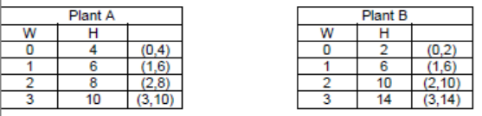  Given each set of coordinates, graph their corresponding lines.  Solution:  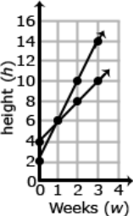 (Continued on next page)
8.EE.7.Solve linear equations in one variable.  - Give examples of linear equations in one variable with one solution, infinitely many solutions, or no solutions. Show which of these possibilities is the case by successively transforming the given equation into simpler forms, until an equivalent equation of the form x = a, a = a, or a = b results (where a and b are different numbers).  - Solve linear equations with rational number coefficients, including equations whose solutions require expanding expressions using the distributive property and collecting like terms. | Given each set of coordinates, graph their corresponding lines.  Solution:  Write an equation that represent the growth rate of Plant A and Plant B.  Solution:  Plant A H = 2W + 4  Plant B H = 4W + 2  • At which week will the plants have the same height?  Solution:  The plants have the same height after one week.  Plant A: H = 2W + 4 Plant B: H = 4W + 2  Plant A: H = 2(1) + 4 Plant B: H = 4(1) + 2  Plant A: H = 6 Plant B: H = 6  After one week, the height of Plant A and Plant B are both 6 inches.  This supporting standard must be previously mastered in Unit 4 for students to be successful with Unit 5.
8.F.2. Compare properties of two functions each represented in a different way (algebraically, graphically, numerically in tables, or by verbal descriptions). For example, given a linear function represented by a table of values and a linear function represented by an algebraic expression, determine which function has the greater rate of change.  8.F.4. Construct a function to model a linear relationship between two quantities. Determine the rate of change and initial value of the function from a description of a relationship or from two (x, y) values, including reading these from a table or from a graph. Interpret the rate of change and initial value of a linear function in terms of the situation it models, and in terms of its graph or a table of values. | This supporting standard must be previously mastered in Unit 4 for students to be successful with Unit 5.  This supporting standard must be previously mastered in Unit 4 for students to be successful with Unit 5.

Concepts  What Students Need to Know | Skills  What Students Need To Be Able To Do | Bloom’s Taxonomy Levels
Linear Equations (Simultaneous/system of)  - Rational Number Coefficients  - One variable  - One solution  - Many solutions  - No solutions  Equations into simpler forms  - Expanding Expressions  - Distributive Property  - Combining Like Terms  Function  - Rate of change  - Initial value (of a linear function)  - Representation  - Algebraically  - Graphically  - Numerically in tables  - Verbal description | Solve (linear equations)  Show (simpler forms)  Analyze (linear equations)  Understand (solutions)  Solve (systems of equations)  Estimate (solutions)  Graph (equations)  Solve  - (simple cases by inspection)  - In context  Construct (function)  Determine (rate of change and initial value of the function)  Read (table and graph)  Interpret (rate of change and initial value of a linear function  COMPARE (functions represented differently) | 3  2  4  2  3  3  3  3  3  3  2  2  4

Essential Questions

Corresponding Big Ideas

Standardized Assessment Correlations
(State, College and Career)
Expectations for Learning (in development)
This information will be included as it is developed at the national level. CT is a governing member of the Smarter Balanced Assessment Consortium (SBAC) and has input into the development of the assessment.

Tasks
These tasks can be used during the course of instruction when deemed appropriate by the teacher.
Notebooks and Pens and Cash Registers
(Students compare two equations with two variables in two separate but similar contexts. Each problem is done individually, but students are also asked to describe and analyze sample student work containing different strategies for completing problems of this type. They are then encouraged to revise their work on the problems based on their findings.
http://map.mathshell.org/materials/download.php?fileid=669

Unit Assessments
The items developed for this section can be used during the course of instruction when deemed appropriate by the teacher.
- Solve the system of linear equations below.

8x – y = 20
y = 3x

Show or explain how you found your answer.

Answer: x = 4, and y = 12, or the ordered pair, (4, 12) (Transcribing the two values as (12, 4) may be awarded full credit if student work shows clear understanding of the task.) with an explanation showing the method used to solve the system.

Partial Credit: Correct answer (4,12) with an incorrect or missing explanation, OR and incorrect answer with an explanation that demonstrates understanding of solving the system.

No Credit: Incorrect answer with an incorrect or missing explanation.

- Look at the graph below.
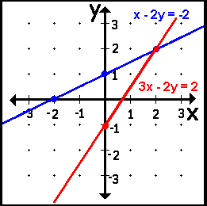

What is the solution of this system of linear equations? Write your answer as an ordered pair, (x, y). Show or explain how you found your answer.

Answer: (2, 2) with an explanation the may include:
- (2, 2) is the point of intersection of the two lines in the figure OR
- if the system of linear equations, x – 2y = -2 and 3x – 2y = 2 is solved algebraically, the solution is (2, 2) OR
- if the coordinates of the point (2, 2) are substituted into both equations, the equations will be true statements, -2 = -2 and 2 = 2, respectively.

Partial Credit: Correct answer (2, 2) with an incorrect or missing explanation, OR and incorrect answer with an explanation that demonstrates understanding of solving the system.

No Credit: Incorrect answer with an incorrect or missing explanation.

- Solve the system of linear equations below.

4x – 3y = 5
4x – 3y = 7

Show or explain how you found your answer.

Answer: No solution or ø with an explanation that may include:
- 4x – 3y cannot be equal to both 5 and 7 OR
- Graphing the equations results in parallel lines or lines that do not intersect OR
- Solving the system algebraically results in a false equation like 5 = 7 or 0 = 2.

Partial Credit: Correct answer, No solution, with an incorrect or missing explanation, OR and incorrect answer with an explanation that demonstrates understanding of solving the system.

No Credit: Incorrect answer with an incorrect or missing explanation.

- Two options for Online Music Clubs are described in the table below.
Online Music Club Options
 | Monthly Rate | Additional charge per song download
Club A | $15 | $0.40
Club B | $25 | $0.20

For what number of songs will the monthly charge be the same? Show or explain how you found your answer.
Answer: 50 songs with an explanation that may include:
- A graph of the situation
- Solution of the system y = 0.4x + 15 and y = 0.2x + 25
- A table of values showing that the monthly charge is the same for 50 songs
Partial Credit: Correct answer, 50 songs, with an incorrect or missing explanation, OR and incorrect answer with an explanation that demonstrates understanding of solving the system.

No Credit: Incorrect answer with an incorrect or missing explanation.

- Look at the graph below:
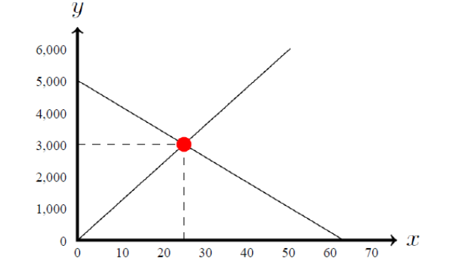
Describe a situation or scenario that can be solved using the graph. Include an explanation of the solution of the system of linear
equations shown in the graph.

Answer: The student writes a context that makes sense for both lines/equations, y = 120x and y = -80x + 5000, and explains the point of intersection (solution) correctly using this context.

Context might include:
- A supply and demand model
- Two planes – one landing and one taking off – the point of intersection is when they will be at the same altitude
- Increasing/decreasing values of a commodity

Partial Credit: Correct context, with an incorrect or missing explanation of the solution, OR an incorrect context with a correct explanation of the solution of the system of linear equations.
No Credit: Incorrect context with an incorrect or missing explanation of the solution.

Pacing: 2 weeks (plus 1 week for reteaching/enrichment)
Mathematical Practices
Mathematical Practices #1 and #3 describe a classroom environment that encourages thinking mathematically and are critical for quality teaching and learning.

Practices in bold are to be emphasized in the unit.
1. Make sense of problems and persevere in solving them.
2. Reason abstractly and quantitatively.
3. Construct viable arguments and critique the reasoning of others.
4. Model with mathematics.
5. Use appropriate tools strategically.
6. Attend to precision.
7. Look for and make use of structure.
8. Look for and express regularity in repeated reasoning.

Domain and Standards Overview
Geometry
- Solve real-world and mathematical problems involving volume of cylinders, cones, and spheres.

Priority and Supporting CCSS | Explanations and Examples*
8.G.9. Know the formulas for the volumes of cones, cylinders and spheres and use them to solve real-world and mathematical problems. | 8.G.9. Example:  • James wanted to plant pansies in his new planter. He wondered how much potting soil he should buy to fill it. Use the measurements in the diagram below to determine the planter’s volume.  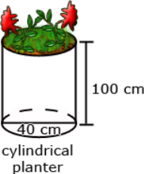

Concepts  What Students Need to Know | Skills  What Students Need To Be Able To Do | Bloom’s Taxonomy Levels
Formulas (volume)  - Cones  - Cylinders  - Spheres | - Know (formulas for volumes)  - Use (formulas for volumes)  - Solve (in context) | 2  3  3

Essential Questions

Corresponding Big Ideas

Standardized Assessment Correlations
(State, College and Career)
Expectations for Learning (in development)
This information will be included as it is developed at the national level. CT is a governing member of the Smarter Balanced Assessment Consortium (SBAC) and has input into the development of the assessment.

Unit Assessments
The items developed for this section can be used during the course of instruction when deemed appropriate by the teacher.

Pacing: 3 weeks (plus 1 week for reteaching/enrichment
Mathematical Practices
Mathematical Practices #1 and #3 describe a classroom environment that encourages thinking mathematically and are critical for quality teaching and learning.

Practices in bold are to be emphasized in the unit.
1. Make sense of problems and persevere in solving them.
2. Reason abstractly and quantitatively.
3. Construct viable arguments and critique the reasoning of others.
4. Model with mathematics.
5. Use appropriate tools strategically.
6. Attend to precision.
7. Look for and make use of structure.
8. Look for and express regularity in repeated reasoning.

Domain and Standards Overview
Statistics and Probability
- Investigate patterns of association in bivariate data.

Priority and Supporting CCSS | Explanations and Examples*
8.SP.1. Construct and interpret scatter plots for bivariate measurement data to investigate patterns of association between two quantities. Describe patterns such as clustering, outliers, positive or negative association, linear association, and nonlinear association.  8.SP.4. Understand that patterns of association can also be seen in bivariate categorical data by displaying frequencies and relative frequencies in a two-way table. Construct and interpret a two-way table summarizing data on two categorical variables collected from the same subjects. Use relative frequencies calculated for rows or columns to describe possible association between the two variables. For example, collect data from students in your class on whether or not they have a curfew. | 8.SP.1. Students build on their previous knowledge of scatter plots examine relationships between variables. They analyze scatter plots to determine positive and negative associations, the degree of association, and type of association. Students examine outliers to determine if data points are valid or represent a recording or measurement error. Students can use tools such as those at the National Center for Educational Statistics to create a graph or generate data sets. (http://nces.ed.gov/nceskids/createagraph/default.aspx)  Examples:  • Data for 10 students’ Math and Science scores are provided in the chart. Describe the association between the Math and Science scores.  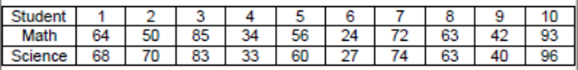  • Data for 10 students’ Math scores and the distance they live from school are provided in the table below. Describe the association between the Math scores and the distance they live from school.  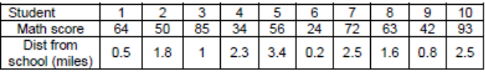  • Data from a local fast food restaurant is provided showing the number of staff members and the average time for filling an order are provided in the table below. Describe the association between the number of staff and the average time for filling an order.  • The chart below lists the life expectancy in years for people in the United States every five years from 1970 to 2005. What would you expect the life expectancy of a person in the United States to be in 2010, 2015, and 2020 based upon this data? Explain how you determined your values.  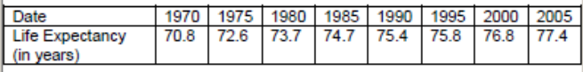  8.SP.4. Example:  • The table illustrates the results when 100 students were asked the survey questions: Do you have a curfew? and Do you have assigned chores? Is there evidence that those who have a curfew also tend to have chores?  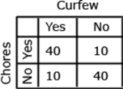  Solution: Of the students who answered that they had a curfew, 40 had chores and 10 did not. Of the students who answered they did not have a curfew, 10 had chores and 40 did not. From this sample, there appears to be a positive correlation between having a curfew and having chores.
8.SP.3. Use the equation of a linear model to solve problems in the context of bivariate measurement data, interpreting the slope and intercept. For example, in a linear model for a biology experiment, interpret a slope of 1.5 cm/hr as meaning that an additional hour of sunlight each day is associated with an additional 1.5 cm in mature plant height. | 8.SP.3. Examples:  • 1. Given data from students’ math scores and absences, make a scatter plot.  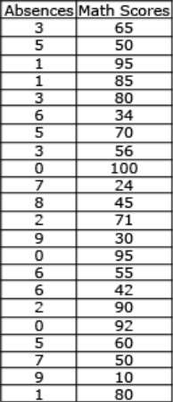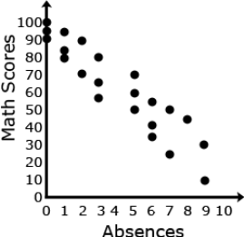  2. Draw a line of best fit, paying attention to the closeness of the data points on either side of the line.  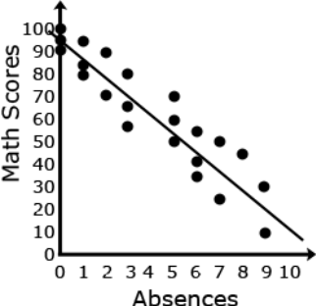  (Continued on next page)
8.SP.2 Know that straight lines are widely used to model relationships between two quantitative variables. For scatter plots that suggest a linear association, informally fit a straight line, and informally assess the model fit by judging the closeness of the data points to the line. | • 3. From the line of best fit, determine an approximate linear equation that models the given data (about y = − x +95)  • 4. Students should recognize that 95 represents the y-intercept and – represents the slope of the line.  • 5. Students can use this linear model to solve problems. For example, through substitution, they can use the equation to determine that a student with 4 absences should expect to receive a math score of about 62. They can then compare this value to their line.  8.SP.2 Examples:  • The capacity of the fuel tank in a car is 13.5 gallons. The table below shows the number of miles traveled and how many gallons of gas are left in the tank. Describe the relationship between the variables. If the data is linear, determine a line of best fit. Do you think the line represents a good fit for the data set? Why or why not? What is the average fuel efficiency of the car in miles per gallon?  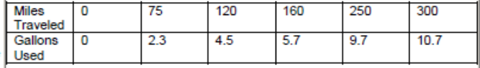

Concepts  What Students Need to Know | Skills  What Students Need To Be Able To Do | Bloom’s Taxonomy Levels
Scatter Plots  Patterns  - Clustering  - Outliers  - Positive or Negative  - Linear  - Nonlinear  Frequencies  Two-way table  - variables  Equation of Linear Model  - Slope and Intercept  Line of best fit | - CONSTRUCT (scatter plots)  - INTERPRET (scatter plots)  - INVESTIGATE (patterns)  - DESCRIBE (patterns)  - USE (equation of a linear model)  - SOLVE (in context)  - INTERPRET (slope and intercept)  - UNDERSTAND (patterns of association in data)  - DISPLAY (frequencies and relative frequencies)  - DESCRIBE (association between variables)  - DRAW (line of best fit) | 3  2  4  1,2  3  4  4  2  3  2  3

Essential Questions

Corresponding Big Ideas

Standardized Assessment Correlations
(State, College and Career)
Expectations for Learning (in development)
This information will be included as it is developed at the national level. CT is a governing member of the Smarter Balanced Assessment Consortium (SBAC) and has input into the development of the assessment.

Unit Assessments
The items developed for this section can be used during the course of instruction when deemed appropriate by the teacher.

