1.
18 % $\sqrt{4}$ $0.\overline{4}$ $\sqrt{15}$ -8 $\sqrt{2}$ $π$
- From the bank above, which numbers are considered rational?

- Which are considered irrational?

- Explain in writing how can you tell the difference between rational and irrational numbers?

2. a) Evaluate the following rational expressions using whole numbers:
$\sqrt{16}$ =
$\sqrt{25}$ =

b) Is $\sqrt{20}$ a rational or irrational number? Explain how you know.

____________________________________________________________________________________________________________________________________________________________________________________________________________________________________________________________________________

c) Approximate $\frac{\sqrt{12}}{4}$ to the nearest whole number.

- Approximate $\sqrt{12}-2$ to the nearest tenth.

- Justify your approximation for d.

_______________________________________________________________________________________________________________________________________________________________________________________________________________________________________________________________________________________________________________________________________________

3. Using your knowledge of perfect squares, find the approximate location of the irrational number $\sqrt{30}$ on the number line below. How did you determine this location? Please provide an in-depth explanation on the lines below.

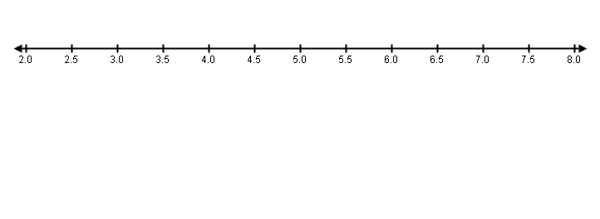
______________________________________________________________________________________________________________________________________________________________________________________________________________________________________________________________________________________________________________________________________________________________________________________________________________________________________________________________________________________________________________________________

4. Order $\sqrt{5}$ , 220%, 2.25 and 2.$\overline{2}$ from least to greatest. Verify your answer by graphing on number line.

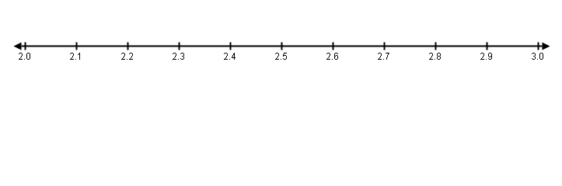

5. Explain if the following statement is always, sometimes, or never true. Use mathematical reasoning in your answer. Use the bank below to help you answer the question.

Is this statement always true? Sometimes true? Never true?

The sum of a rational number and an irrational number is irrational.

Use the bank below to help you validate your answer.

$\sqrt{6}$ $\sqrt{49}$ 8 5 + $\sqrt{6}$
6 π $\sqrt{9}$

Common Core Standards

8.NS Know that there are numbers that are not rational, and approximate them by rational numbers.
1. Know that numbers that are not rational are called irrational. Understand informally that every number has a
decimal expansion; for rational numbers show that the decimal expansion repeats eventually, and convert a decimal expansion which repeats eventually into a rational number.

2. Use rational approximations of irrational numbers to compare the size of irrational numbers, locate them
approximately on a number line diagram, and estimate the value of expressions (e.g., π2). For example, by
truncating the decimal expansion of √2, show that √2 is between 1 and 2, then between 1.4 and 1.5, and explain how to continue on to get better approximations.

8.EE.2 Use square root and cube root symbols to represent solutions to equations of the form x2 = p and x3 = p, where p is a positive rational number. Evaluate square roots of small perfect squares and cube roots of small perfect cubes. Know that √2 is irrational.

Score | Description
4 | - Students are able to make approximations of irrational numbers and justify their reasoning for doing so.  - Students are able to show approximations in a number of ways, including on a number line.  - Students are able to tell the difference between rational and irrational numbers expressed in multiple ways.  - Students are able to order irrational numbers based on their approximations.  - Students are able to prove a mathematical theorem by testing a hypothesis and providing evidence to support.
3 | - Students are able to make approximations of irrational numbers but only provide a partial reasoning.  - Students are able to tell the difference between rational and irrational numbers in at least 1 way (numerically or graphically).  - Students are able to order irrational numbers based on their approximations.  - Students attempt to prove a mathematical theorem by testing a hypothesis but do not provide adequate justification and evidence.
2 | - Students are able to make most approximations of irrational numbers but may fail to provide adequate reasoning.  - Students are able to tell the difference between rational and irrational numbers in at least 1 way (numerically or graphically).  - Students attempt to order irrational numbers on a number line but may fail to do so because of a computational error.  - Students attempt to prove a mathematical theorem by testing a hypothesis but do not provide any justification or evidence.
1 | - Students are able to make some approximations of irrational numbers but fail to provide reasoning.  - Students struggle to differentiate between rational and irrational numbers.  - Students attempt to order irrational numbers on a number line but may fail to do so because of a computational error.  - Students fail to prove a mathematical theorem, or make a mathematical statement about a hypothesis without any justification or evidence.

