Name _________________________________ IS 259
Date ___________ Class ________ Grade 8 Math Quiz 14
SHOW ALL YOUR WORK. ANSWER ALL QUESTIONS ON GRAPH PAPER!!!!!!!!!! USE PENCIL
Match the following equation with its matching table and graph (choices a – f)
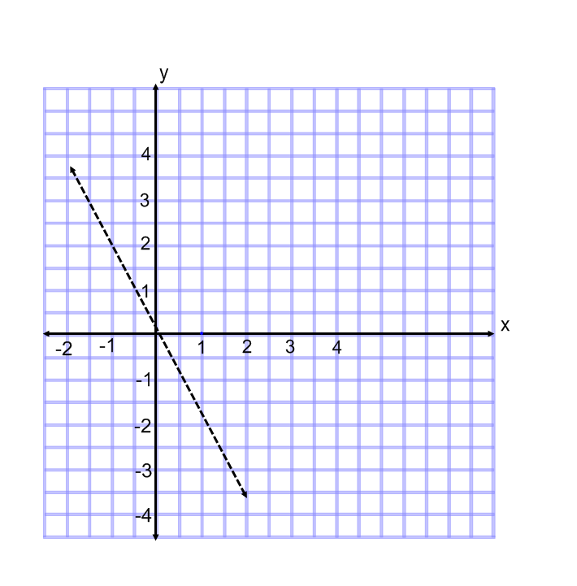
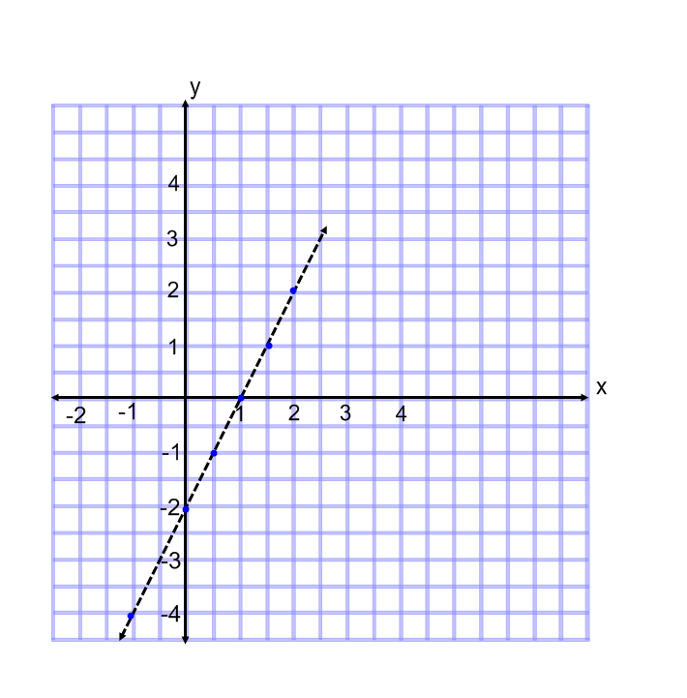
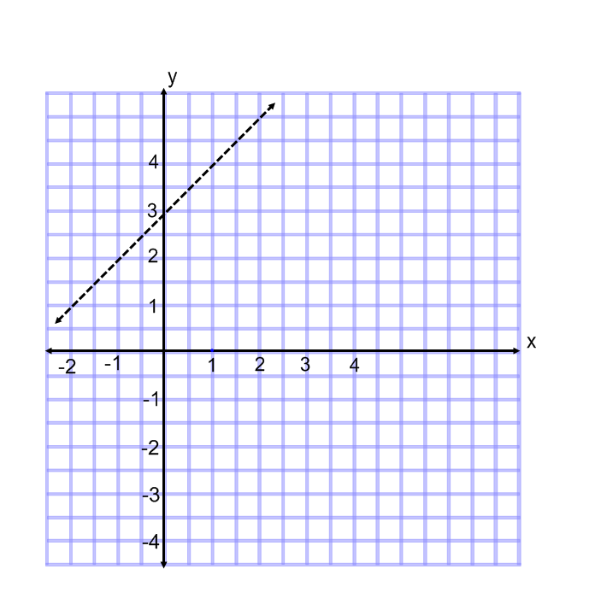
1. y = 2x – 2 Graph: ________ 2. y = - 2 x Graph: _______ 3. y = x + 3 Graph: _______
Table: ________ Table: _______ Table: _______
a) b) c)

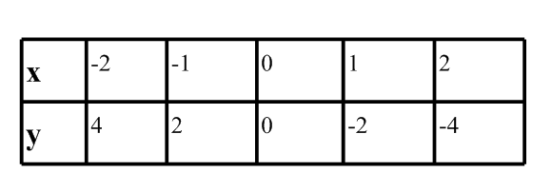
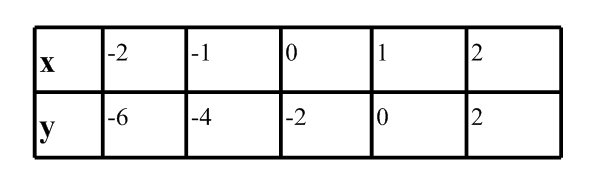
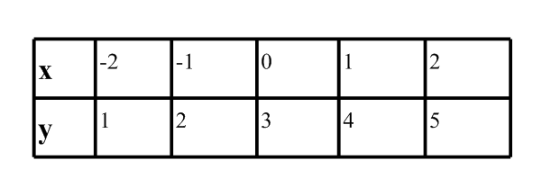
d) e) f)

For the following questions, find the slope using two points.
m = $\frac{y_{2 -}{ y}_{1}}{x_{2} - x_{1}}$
4. ( -2 , -4) and ( 1, -1) 6. ( 0, -2) and (3, -3)
5. ( - 1 , 6) and ( 2, -12 ) 7. (0, 5) and (3, 8)

You MUST do the following problem:
8. Pick ONE pair of points from one of the questions 4 – 7 above.
a) Graph the 2 points
b) draw a line connecting them
c) draw arrows at each end of the line
d) label the line with its equation.

For the following questions, write an equation that matches the table.
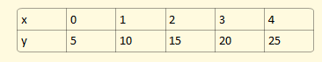
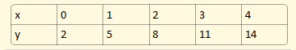
9. 10.

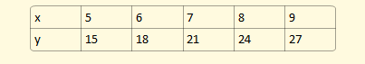
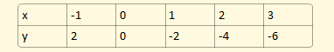
11. 12.

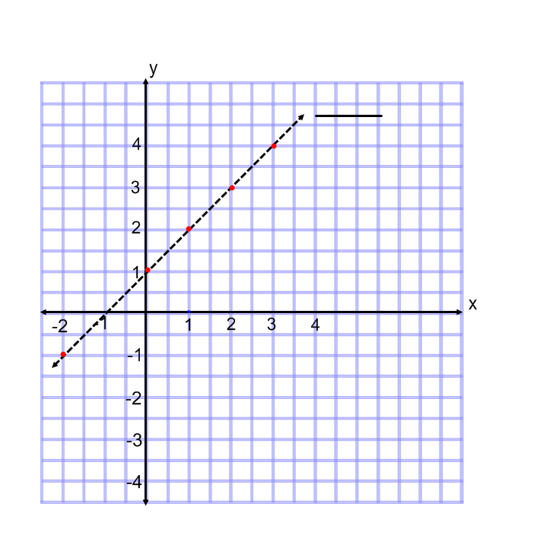
12. and 13. Choose two of the tables above and graph the two lines on the SAME set of axes. Make sure you draw arrows and label the lines with their equations.

Use the following graph to answer the next few questions:
14. What is the slope of the line ?
15. What point is the y – intercept?
16. The general form of a line is given by y = mx + b
What do m and b stand for?
______________________________________
17. What is the equation of the line in the graph?

Graph the following two linear functions on the same set of axes. Use values -3 < x < 3.
y = 2 x + 1
y = 2x - 6

18. How are these two lines similar? How are they different?

19. Make a deduction about lines with the same slope. How will two lines with the same slope appear graphically?

