Name _________________________________ IS 259
Grade 8 Math Exam: Transformations Mr. Frangella
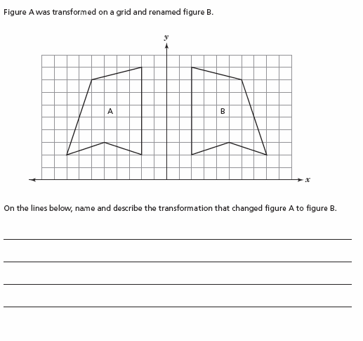
1)

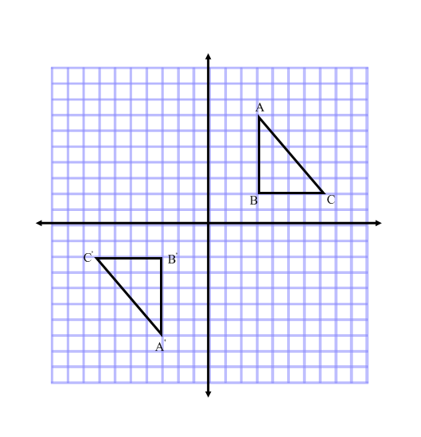

2) What transformation is performed on ABC? Explain.

_______________________________________

_______________________________________

_______________________________________

_______________________________________

_______________________________________

3)
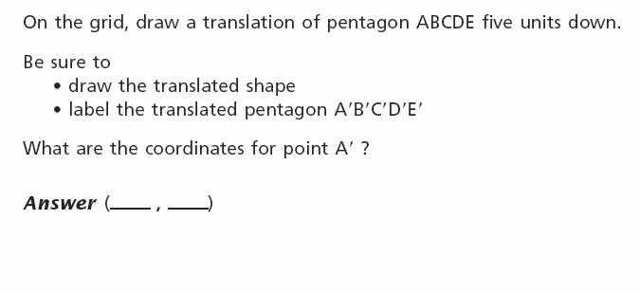
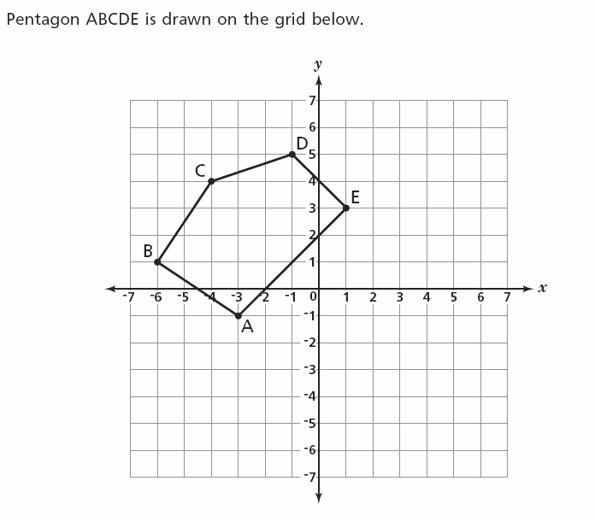
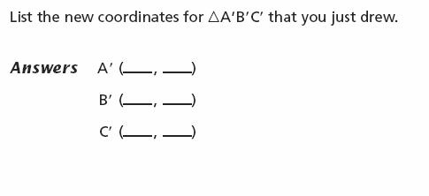
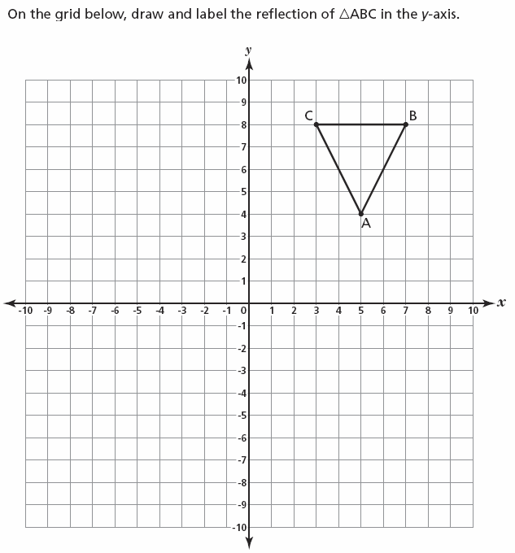
4)

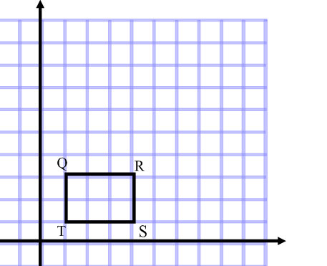
5) A) Dilate the following figure by a scale
factor of 2. Label it Q’R’S’T’

B) List the coordinates of each point:

Q’ =

R’ =

S’ =

T’ =

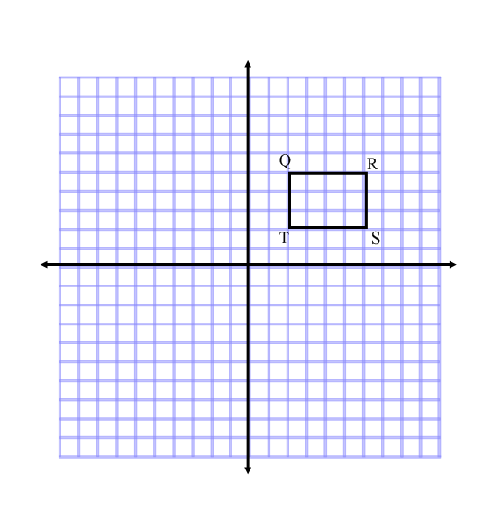

6)

- Draw the reflection of QRST over the x –axis. Label the figure Q’R’S’T’

- Rotate the reflected image Q’R’S’T’ about the origin 180° counterclockwise. Label the figure Q’’R’’S’’T’’.

- Dilate the figure Q’’R’’S’’T’’ by a scale factor of ½. Label the figure Q’’’R’’’S’’’T’’’

- Q’’’=
R’’’ =
S’’’ =
T’’’ =

