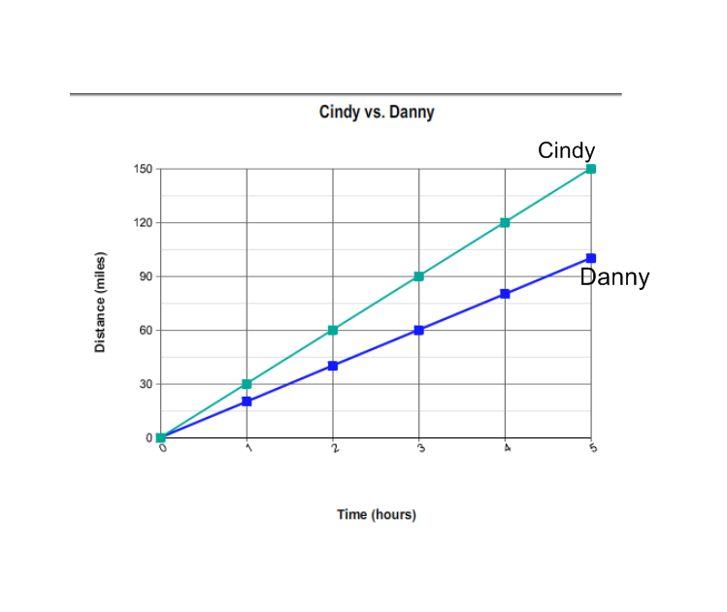
Name __________________________ Class _______________ Date _______________
Multiple Choice
____ 1. Cindy and Danny are both traveling in different cars.
The function that represents each of their speeds is
shown in the graph below. Which of the statements
below is true?
a) Cindy is traveling faster, at a rate of 20 miles per hour. | b) Cindy is traveling faster, at a rate of 30 miles per hour.
c)Danny is traveling faster, at a rate of 30 miles per hour. | d) Danny is traveling faster, at a rate of 20 miles per hour.

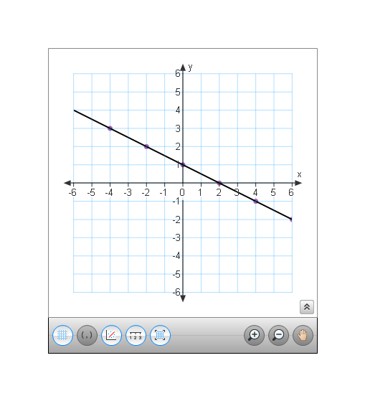
____ 2. What is the equation of the line shown at right?
a) y = $\frac{1}{2}$ x + 1 | b) y = 2x + 1
c) y = - $\frac{1}{2}$ x + 1 | d) y = - 2x + 1

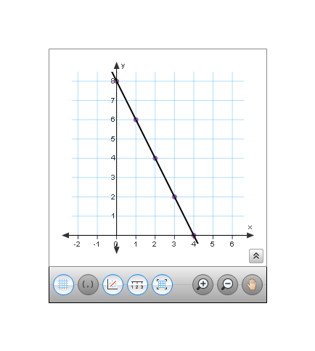
a) y = -2 x + 8 | b) y = - $\frac{1}{2}$x + 8
c) y = 8x -2 | d) y = 2x + 8
____ 3. What equation is represented by the function graphed below?

_____ 4. Which of the following graphs is an example of a linear function?
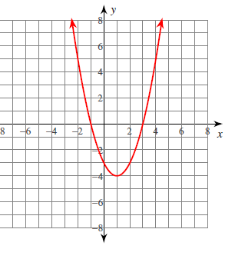 | 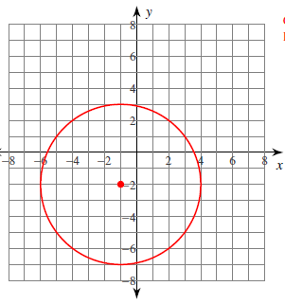  b) | c) 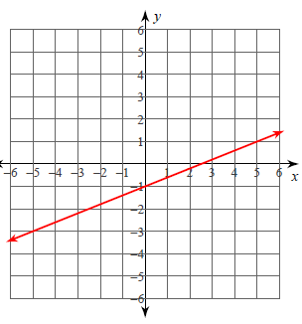 | 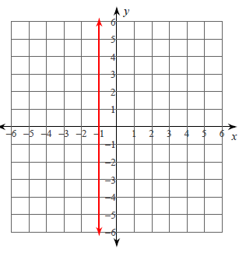  d)

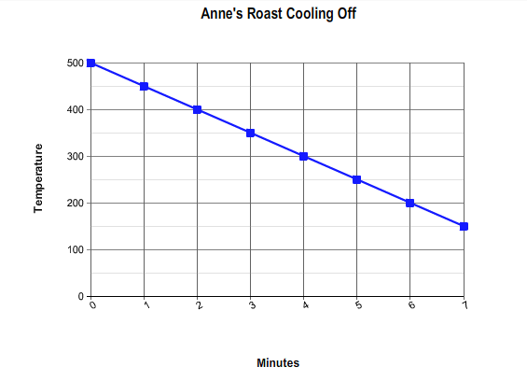
_____5. Anne just finished cooking a roast beef in her oven. She takes it out and waits for it to cool down. As it cools, she records the temperature and makes the graph shown below. Which of the following statements is true based on the graph?
a) The roast starts at 500 degrees and cools at a rate of 50 degrees every minute. | b) The roast starts at 50 degrees and cools at a rate of 500 degrees every minute.
c) The roast starts at 500 degrees and cools at a rate of 100 degrees every minute. | d)The roast starts at 500 degrees and heats up at a rate of 50 degrees every minute.

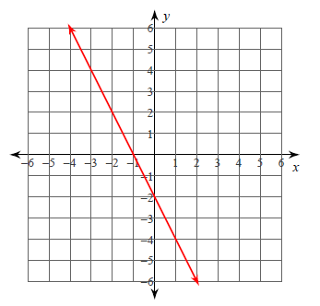
____ 6. Which of the following linear functions is parallel to the function graphed below?

a) y = - $\frac{1}{2}$ x + 3 | b) y = 2x + 1
c) y = - 1 x + 1 | d) y = - 2x + 3

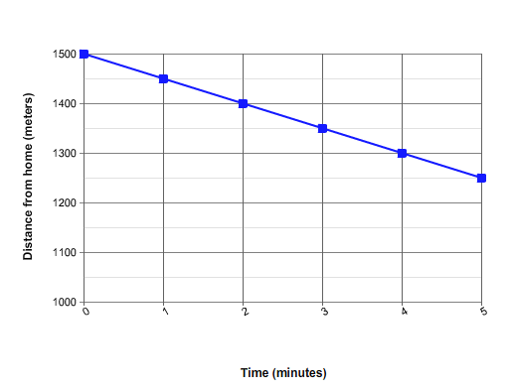
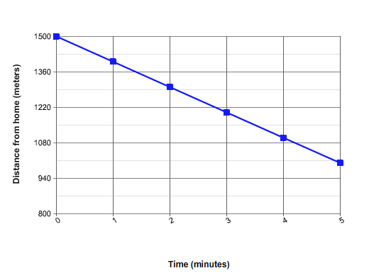
_____ 7. Jason is riding his bike home from school. His school is 1500 meters away from his house, and he is riding home at a speed of 100 meters per minute. Which of the following graphs correctly displays Jason’s data?
- b)

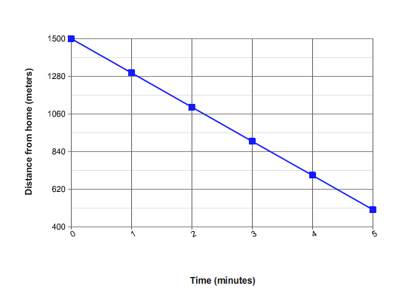
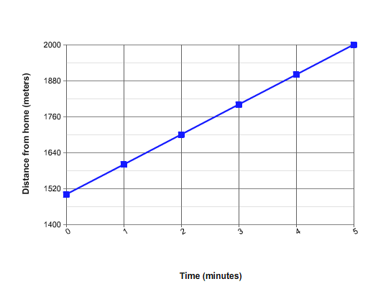
c) d)

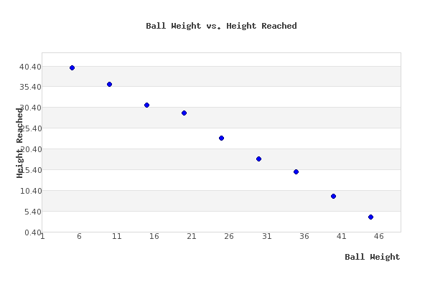
____ 8. Some students are experimenting how high a ball can reach if it is thrown in the air, depending on its weight. Describe the kind of association that is represented in the scatterplot below:
a) Positive Association: As the ball’s weight increases, the height reached also increases. | b) Negative Association: As the ball’s weight increases, the height it can reach decreases.
c) No association: There is no relationship between the ball’s weight and the height it can reach. | d)Negative association: As the ball’s weight increases, the height it can reach also increases.

Extended Response Questions
X | Y
7 | 23
9 | 29
-3 | -7
-8 | -22
- Line A Line B
X | Y
8 | 19
10 | 23
-6 | -9
-4 | -5

- Find the equation of each linear function expressed in the tables above.

Line A _________________ Line B _________________
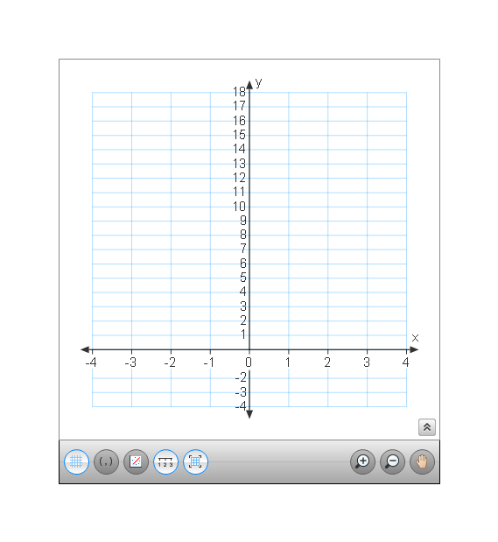
- Graph both functions on the same set of axes using domain values: [-3, -2, -1, 0, 1, 2, 3]

- Compare and contrast the lines using at least two pieces of information from the graph, table or equation.

___________________________________________________________________________________________________________________________________________________________________________________________________________________________________________________________________________________________________

- Determine if the two functions expressed in the tables below represent parallel lines.
Line A Line B
Input | Output
-3 | 7
3 | 17
11 | 49
15 | 65
Input | Output
9 | 36
7 | 28
10 | 40
18 | 72

- Explain how you established whether or not the lines are parallel.

______________________________________________________________________________________________________________________________________________________________________________________________________________________________________________________________________________________________________

- Does one of the functions represent a Direct Variation? How do you know?

______________________________________________________________________________________________________________________________________________________________________________________________________________________________________________________________________________________________________

___________________________________________________________________________________________________________________________
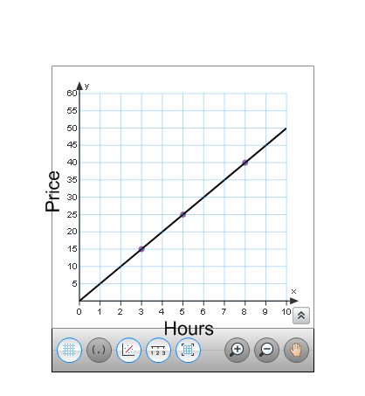
- Two competing limousine companies are trying to create formulas to help their customers determine how much they will have to pay depending on how many hours they will rent the limo. The following table and graph show how much money the companies want to charge per hour used.
Larry’s Limos Randy’s Rides
Hours | Dollars
2 | 14
4 | 22
8 | 38
12 | 54

- Write an equation using dollars, d, and hours, h, to determine the rate at which the companies charge per hour.
Larry’s Limos Randy’s Rides
- Which company is the smarter purchase? Write an explanation to justify your answer.
____________________________ ________________________________________________________________________________________________________________________________________________________________________________________________________________________
- What would be the difference in price for the two companies if you decided to rent a limo for 24 hours? Show your work.

Answer_______________
________________________________________________________________________________________________________________
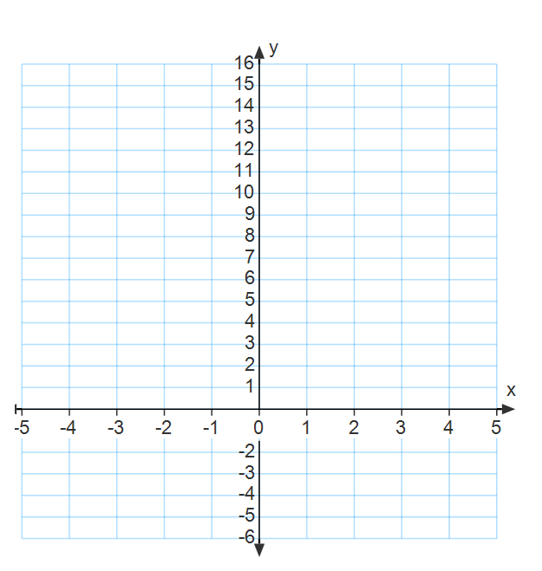
- Two functions are shown below. Function P is represented as an equation, Function Q as a table.

Function P Function Q
y= 6x+2
X | Y
-3 | 9
-2 | 4
-1 | 2
0 | 0
1 | 2
2 | 4
3 | 9

Which of the two functions is NOT linear? Which one is linear? How do you know? Give two supporting reasons from the table, equation, or graph.
__________________________________________________________________________________________________________________________________________________________________________________________________________________________________________________________________________________________________________________________________________________________________________________________________________________________________________________________________________

Question # | Standard Addressed
1 | 8EE5
2, 3 | 8EE6
4 | 8F3
5 | 8F4
6, 7 | 8F5, 8EE6
8 | 8SP2
9 | 8F4, 8F5
10 | 8EE5, 8EE6
11 | 8F4, 8F5
12 | 8F3

