Name _________________________________ Class _____________ Date ___________

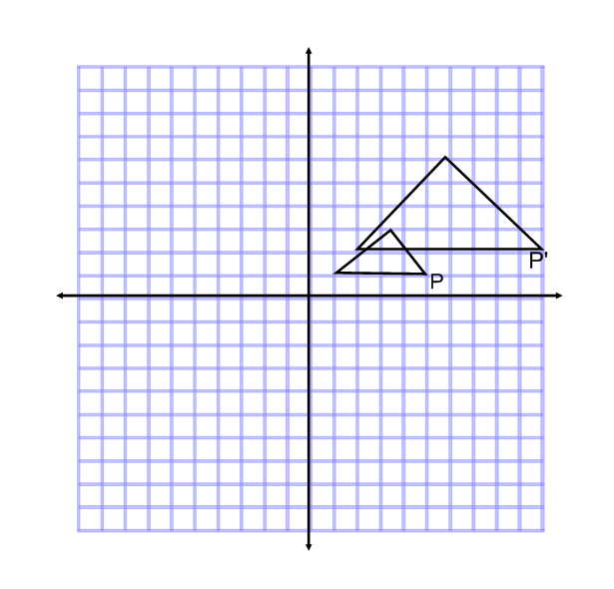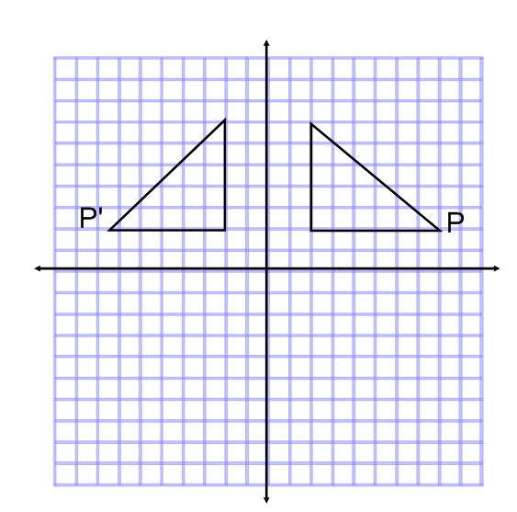***Multiple Choice: Name the type of transformation seen in the picture***

1) 2)

1. Reflection over the x-axis a) Translation 5 units to the right and 1 unit up
2. Reflection over the y-axis b) Dilation of scale factor 2
3. Rotation 90 degrees counterclockwise c)Dilation of scale factor ½.
4. 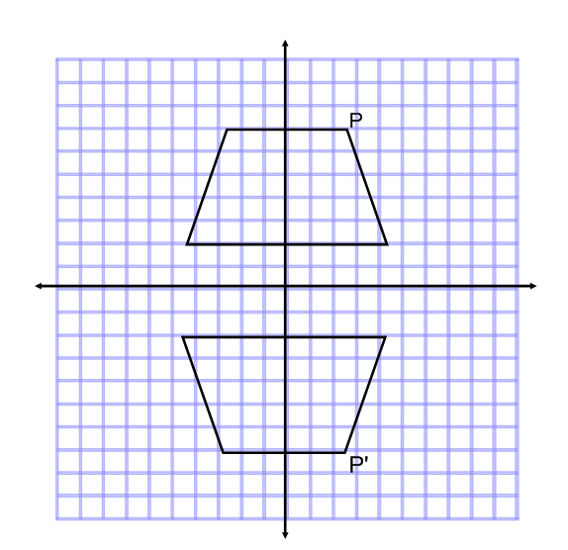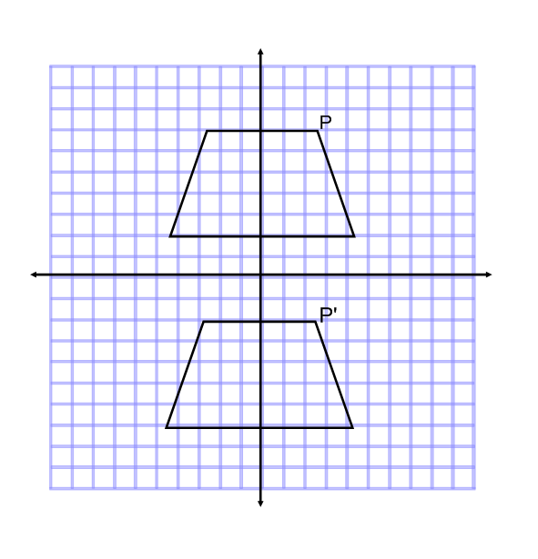Rotation 90 clockwise d) Dilation of scale factor 3.

3) 4)

1. Reflection over the x-axis a) Reflection over the x-axis
2. Reflection over the y-axis b) Reflection over the y-axis
3. Translation 9 units up c) Rotation 180 degrees clockwise
4. 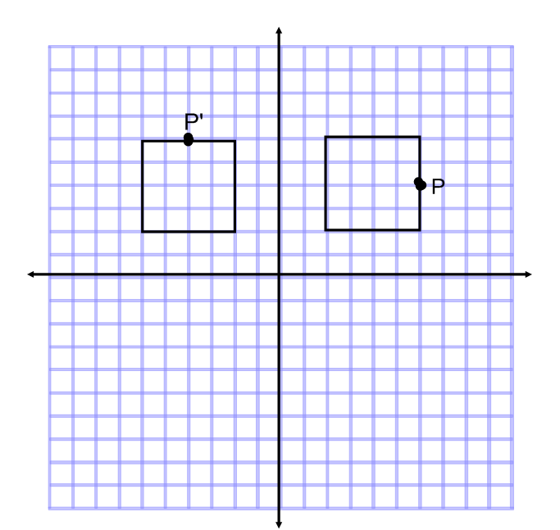Translation 9 units down d) Reflection over the line y = 0.

5)

a) Rotation 90 degrees clockwise

b) Rotation 90 degrees counterclockwise

c) Rotation 270 degrees counterclockwise

d) Reflection over the y axis

**Please provide a *FULL EXPLANATION*. THIS MEANS *COMPLETE SENTENCES.***

6) James said that the in order to get from ABCD to A’B’C’D’, you could reflect the image across the y-axis. Do you agree with James? Why or why not?

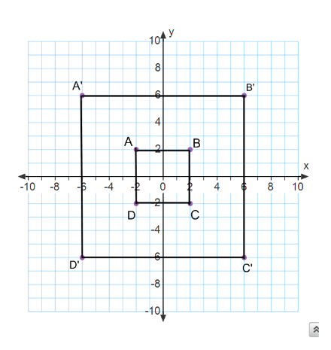

7) Juan put on his test that to get the figure A’B’C’, the original ABC must be dilated by a SCALE FACTOR of 3. Do you agree with Juan? Why or why not?

____________________________________________________

____________________________________________________

____________________________________________________

____________________________________________________

____________________________________________________

____________________________________________________

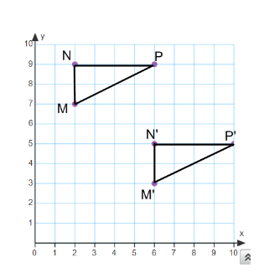________________________________________________________________________________________________

8) ***Use the picture to the right to answer the following questions.***

a) Describe the transformation you see in the picture:

________________________________________________________

b) Fill in the blanks below:

$\overline{MN}$ $≅$________ <M $≅$

$\overline{NP}≅$_________

_________ < P $≅$

_________

Perform the following Transformations

|  |  |
| --- | --- |
| 9) Rotate the figure 180 degrees about the origin. | 10) Reflect the figure across the line ***y = 1*** |

**Answer the following questions on graph paper. Complete all parts of each question on ONE set of axes.**

11) a) Plot the figure ABC, given the coordinates A ( - 5, 3) ; B (-3, 7) ; C ( - 4, 2)

b) Reflect ABC over the x –axis. Label the image A’B’C’. List the coordinates of each point.

12) a) Plot the figure JKLM given the coordinates J ( -6, 3) ; K ( -4, 7) ; L (-2, 6) ; M (-1, 1)

b) Translate the figure 1 unit up and 8 units to the right. Label J’K’L’M’ and list coordinates.

c) Rotate the figure J’K’L’M’ 90 ° counterclockwise about the origin. Label J’’K’’L’’M’’ and list coordinates.

13) a) Plot the figure DFG given the coordinates D (1, 1) ; F (3, 3) ; G ( 4, 1)

b) Dilate DFG by a scale factor of 2. Label the image D’F’G’ and list the coordinates.

c) Reflect D’F’G’ over the line x = 2. Label D’’F’’G’’ and list the coordinates.

d) Are triangles DFG and D’F’G’ similar or congruent? How do you know? Explain.